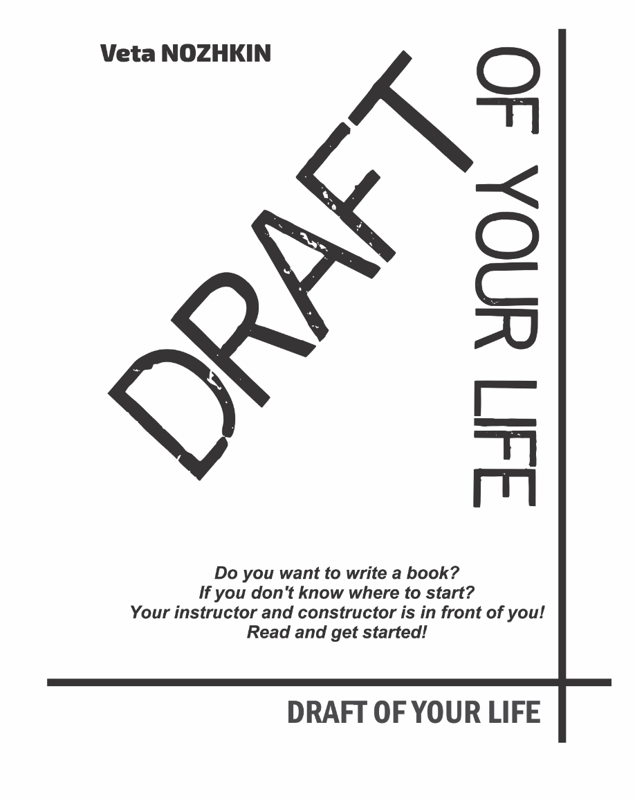
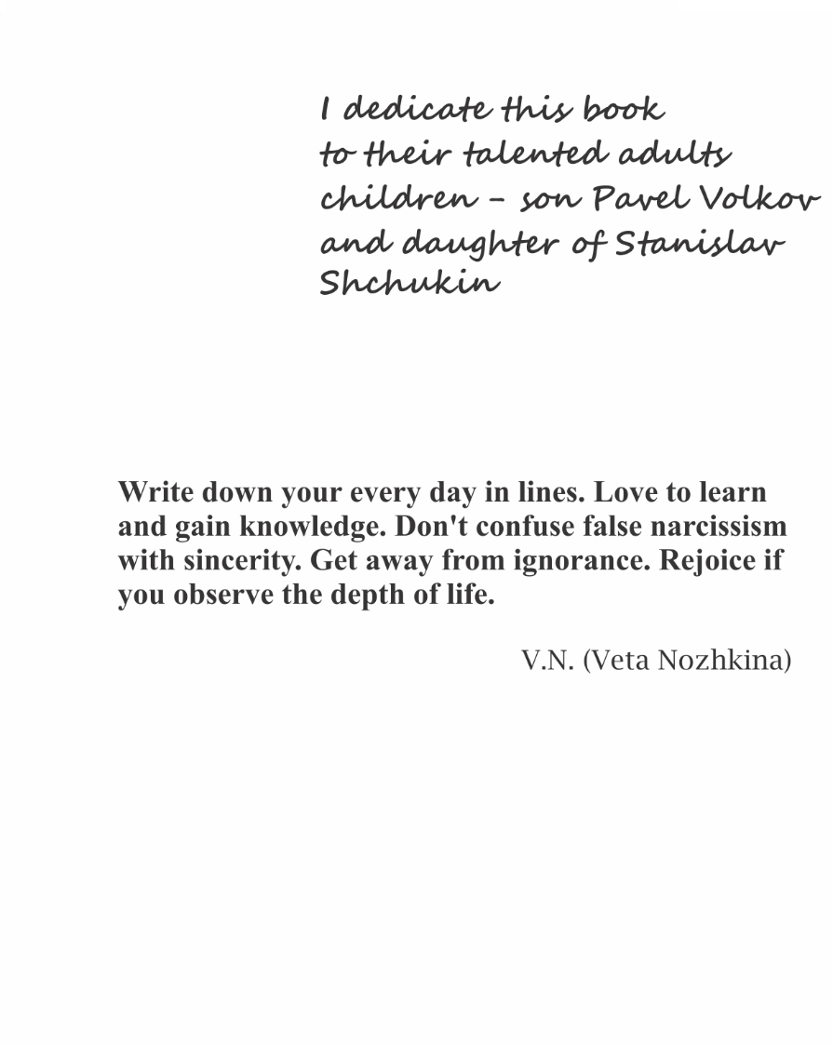

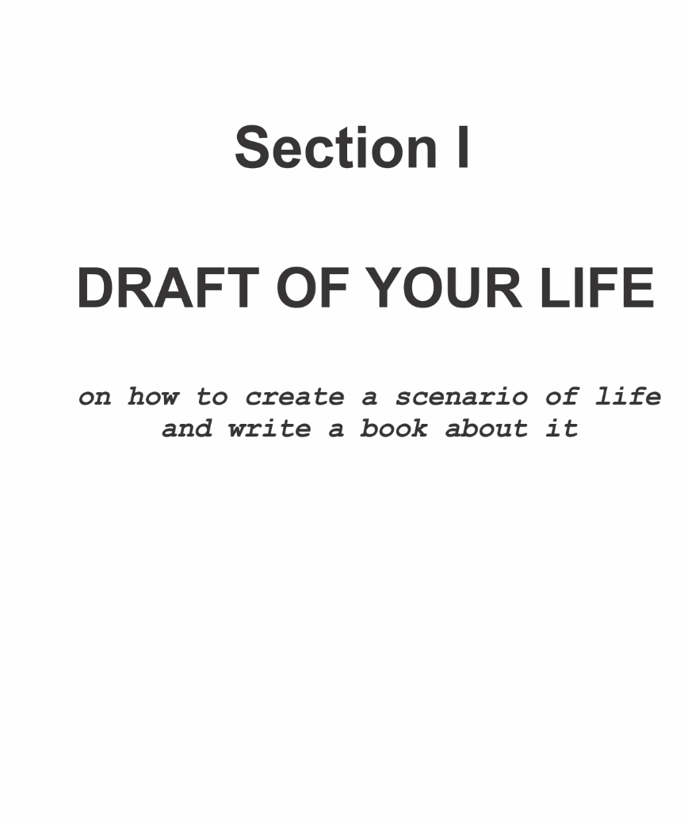

chapter 1. LET’S GET ACQUAINTED?
Hello! You know... the future of this book began a long time ago - from the moment when it became clear to me that the outcome of our lives was a witness to the rules we created. They seem to be dictated to us this way the believers will explain it.
It is not so important "who dictates them": higher powers or mysticism, palmistry, astronomy, physics, and so on. After all, by and large we are all believers. Faith is a guiding star that awakens interest in life. It is she who defines meetings, events, applications of experience and explains our ridiculous mistakes. We ourselves guessed that we were doing our own thing, doing something, but in reality everything is much simpler: you follow an already set trajectory. Your task is to learn how to listen carefully or reject the clues of space and time in which you live every day, gaining experience. In this case, you can create your own rules. This book will tell you how to learn this.
Not everyone thinks about the causes and consequences of events. Therefore, we are different, like flowers in the field, clouds in the sky, colors on the palette of nature. But everyone would like to live this life spectacularly. You make daily mistakes, hit the target, and learn or ignore the lessons given to you. These lessons are the script of your life. You live it every day, as if from scratch. But any scenario can be learned to fix. Without correcting your life, you can remain an addicted person. Do you want to be useful to this world? Take the position of a tactician and strategist, become the leader of your life. The ability to learn to see your life as if from the outside will be a great help to you. This is just what my book will be about - how to arrange your life, how to build relationships with your neighbors in life and, in fact, with the characters of your books. Having learned to build the life of your characters, you will have a completely different attitude towards yourself.
The decision to fit into these pages what was part of my past lectures, classes with students - covered only a part of what had been handed out. But even with the proposed material, you will become the owner of a certain treasure, which, out of the need “for yourself”, can acquire a huge fortune in your head, in your hands.
Looking through these pages, you will not only learn how to write a book, but also gain invaluable experience in creating a script for your life. You will become aware of the details, due to which you can try to influence events. But considering the fact that human cannot be omnipotent, all forethought options can remain a scenario, the elaboration of which will allow you to change, and this is already a great deal.
I hope your changes will go for the better, because the task of this book is to show the human essence with its vices and virtues, which you need to learn to understand. Ideally, it would be useful to everyone, regardless of whether he wants to become a writer or not.
Standing in the center of your world, using your script you will spin this world around you. You will learn what you can take into account preliminarily, what should you focus on, how long it will take to research, to write, who will be your reader, why you will do it, and how you can get along with your inner character. Using classical models, as well as my own experience and the examples of writing books by my students, it will not be difficult for you to understand, consider, hear and see how you can create your own book even in a couple of months, embodying your own ideas on paper. Unless, of course, you are lazy. Your internal core or the call of your ancestors, or, at least, just the desire to live this life remarkably should encourage you.
Pay attention to the words “create a book” (from now on, learn to pay attention and notice everything!), - the terms “to create” and “to write” are different. Writing a book is like a long, drawn-out process. Creation is a purposeful action that has a beginning and an end.
I started writing my very first book many years ago as a student, but I have never finished it. Although ... it only seems to us, that we are making multidirectional movements in life. In fact, we are performing one large, extended in time action, the meaning of which will become clear only at the end of life. Consequently, all the books that I created in adulthood are, in fact, the continuation and completion of that distant original manuscript that I have yet to finish.
“Let the beginning be easy and the end not tiring” - such instructions were given by the main teacher - my father. He taught me to pay attention to details, to the mood of the weather, to a raised eyebrow or a lowered corner of the lip... No, he was not a writer. But he could have become one, if not for the Great Patriotic War of 1941-1945, if not for six years of captivity in a fascist concentration camp, if ...
Dad taught me how to think. He taught me to see and hear this world. His amazing words about people's faces, became clear to me only with the age: “there are no ugly people - there are tired ones”. It was he, my father, who taught me to live among the music of words and just music. What is the most crucial, he taught me to study, constantly, day by day, rejoicing and wondering about the world and the environment, the gifts of fate and its trials. By the virtue of my father, I learned to write poetry, songs and prose.
Perhaps you will want to read what I have written in order to verify, collate, or at least just to be curious - who is in front of you. We all constantly compare something. It is a natural process of self-identification. I am coming to you with an open mind, with my knowledge, sharing the best practices of more than a dozen years, and really want to be useful to you. My works were published in the early tenth of the twenty-first century, so you can find enough information on the Internet by their titles.
«Muleta for Violin» is a novel about graduates of teenage schools, their parents and teachers, about a difficult stage in the formation of a growing person.
«Village Tales» is an ethno-tale of the early twentieth century about the growing up of a boy Mittka, brought up on the tales of a fellow countryman (translated into German and published in Germany).
«The Lost Name» is an adventure novel about the scientist Michael, who came from America to Russia in search of roots.
«Felt-tip pens for Titian» is a collection of stories about human destinies, about chosen priorities, about moral and immoral actions, about setting of life goals, about nobility and joys from small victories, about benefits and delusions.
«Once upon a time there were dolls» - a children's fairy tale about a five-year-old girl Sonya and her adventures (translated into Japanese and published in Japan).
«Hold on to the Sky» is a novel about a young woman, Anna, who keeps a diary to understand the causes of cancer in humans.
I accept this life just the way it is, with the tests given to me. I start every day with the words: «Lord! Thanks for the people around me! ».
I was surrounded by wonderful teachers, with whom Leo Tolstoy, Fyodor Dostoevsky, Anton Chekhov, Mikhail Bulgakov and others entered my world. Thanks to their works, my life has attracted many guests and passers-by, interesting interlocutors, writers, poets, bards, musicians and artists.
Our multifaceted world has developed in such a way that I was lucky to be the sixth child of my wonderful parents. This rainbow sweet childhood was filled with special historical events: I was a member of Young Pioneer and Komsomol organizations. In a small sketch, I described this period like this:

ICE CREAM

Many of us are united by the sun, mountains, Lenin Street, which was once in every Soviet city, and the Murzilka magazine.
But what separates me from many others ... is ice cream. When I buy you ice cream, I look forward to the sweet taste of memories during your art of feasting on this cold formula.
You love it so much that you can knock over a kilogram packaging in one evening, sharing a little with the cat Darwin, who sits opposite and licks his lips seductively.
When a child, ice cream was brought to our city once a week. It was lying on a tray in a stall in the form of a large white cube. And a cuboid saleswoman in a high chef's hat and white apron raked the white mass already flowing along the edges with a spoon and tamped it with effort into a waffle mold. Well, if the form was well fried, then its walls crunched deliciously at first and by the end of the meal did not miss the melted drops.
However my mother liked to repeat:
- What's the use of this ice cream ?! ...
After graduation, I flew for the first time on an airplane. Transfer in Moscow. Waiting for the next flight to Minsk for six hours, and - ice cream: big ice cream in briquettes, then popsicle in a golden wrapper, then crème brлеlée, and then chocolate «Moscow» ...
Then the temperature. Throat.
And childhood is over.

When my childhood suddenly ended, at the same time, changes began at the state level in the form of the collapse of the Soviet Union, perestroika, crises, economic falls, market appearance. There were enough trials in the life of any person during these general changes, and as for me there would be enough for several lives. This special concentrate, given to the body, brain, state and my time, became the very wealth of emotions and moods that I now share. I did not sit idly by or humbly accepting the trials that had fallen, because I realized early on that my coming into life was needed in order to contribute to the transformation at least around me. And when my friends told me: “Where Veta is, it’s interesting there,” I shyly smiled and looked away, but now I realize - yes, it was so. Therefore, I invite you to another fascinating journey, in which I will teach you how to use the accumulated experience, and in particular, I will teach you how to create a script for your segment of life, which might well become a book. The book you will not be ashamed for. Only later it became clear to me: if you do something sincerely, with all the heart, you will never feel ashamed. The shame appears when you try to hit someone taste, indulge your wishful thinking, when you argue without getting at the heart of the problem, when you do not set deliberate goals for yourself.
Let your book be devoid of artificiality. However, in order to achieve this goal you must work hard, and accumulate a rich supply of sensations first. Because neither I, nor anyone else can teach you to feel and think. You are the only one to build your fertile in ideas world in your head. I will just give you a hint - how to do it, what to look for while creating this world.
I won't describe the scope of the writing period, I don't want to limit you, as it was common even before the pandemic period that has engulfed humanity in recent years, with the phrases "write a book in 6, 3, 2 months .... ". Let me just remind you that life is fleeting, and you can only ask a higher forces to "stretch out" time. As for the rest of the steps, you're better off going through them completely. Take stock of your achievements. And only then move forward. To do this, set the right goals, and the vector of correctness will not allow you to stray from the intended path. Any aimless path - it's a deviation, and therefore a waste of time.
Time is the main factor by which your essence is determined: the smart one spends it according to the mind, the stupid one - on stupidity. Remember: the book you are writing or will write is almost the result. It was once believed that a book could be the result of a lifetime. But in our world of speeds, writing one book in a lifetime is a waste. Therefore, do not postpone its creation until the end of life, as its consummation. You have to write daily, and you must start today.
Studying yourself and signing out, you will fill the vacant place with new knowledge, observations, new experience. Your book will help you make new discoveries - within yourself, your environment, your biography and the biography of your ancestors, in your history and the history of all mankind. The deeper you look at yourself, the clearer idea of your future you will have.

Modern man is gradually becoming a professional in different fields, mastering not one profession, but several, sometimes far from related fields. I believe that the time when, in addition to blockchain technology, other similar functions will appear is almost near. Many professions will become outdated; the information field will not be in gadgets, but in lenses. It will become impossible for a person to hide his thoughts, and therefore, the world will become more moral. Writing will become the standard practice for every literate person. All in all, there are many useful properties beyond the ability to write. An ability to think, to analyze, to notice details, to see life in a panoramic view, to be able to compare, to find and separate non-essential are only its small part.
And besides, if you are a businessperson, you just need a book as a funnel into your business, as a final stage, as a business card. Are you talking about the talent? It would be nice to have a talent for writing. Why not to develop it by yourself? For this purpose, delve into the essence of this word. Talent is the largest measure of weight in the ancient world. All meanings ​​entered after this definition are references to the original one. But weight in society, in a community, is an artificially created category for which people set the rules. As for the talent, abilities, or giftedness, there is a high percentage of efficiency, and the rest is your desire. Human talent reveals in the application of experience. And experience, as you know, is "the son of difficult mistakes."
Ability to arrange your desires in life so that their fulfillment leads to the main creative goal is the art. It is the process of creation. Despite the fact that we are talking about marketing strategies do not related to creativity, I will calm you down and we will build your book – in the same way that they create a model and then build buildings, make clothes and design a ship. In these pages, I will show you how to combine the irrational and the rational.

Although the topics of my "educational" book are indicated in the titles of the table of contents, they are ideologically intertwined and repeated incrementally in the subsequent chapters. Just as the curls of a braided girl's hair inosculate in an elaborate pattern. Therefore, I do not recommend focusing only on chapter titles. For example, you will find the topics "abstract", "idea", "form and content" continuing in several chapters. Three curls - will be for us the three main characters required your book: the reader, yourself, and, of course, me.
In the book, you will come across examples mostly taken from personal experience, including professional experience, which confirms the theoretical achievements of decades acquired against the background of my philological education.
The topics of the book are disclosed somewhere deeper, somewhere in theses. My main task is to puzzle, direct and show how you can create a book without wasting time, but concentrating and purposefully working on it at a time convenient for you. Let me remind you that the working period in the life of any person is only 30-40 years (from 20 to 60). How beneficial can you be during this period if you use knowledge and deeply comprehend life?
Let the time of our close communication with you be like a flight. A flight of fantasy - from me to you, and then from you - to your book.
Since childhood, I often see the same dream: as if I can fly, and I teach everyone around me, explaining how easy it is.
In a dream, a whole theory of flight training was built. To take off you just need something:
- - draw air into your lungs (make sure that your chest does not rise when inhaling!),
- - straighten your shoulders, relax your arms and almost connect your shoulder blades,
- - then tilt the body slightly back and give it a powerful push from the abdomen,
- - now run, accelerating, mentally counting exactly ten steps,
- - stand on tiptoe, then exhale loudly
- - and take off!
It is funny, of course. But I really believed it. In a dream I showed other people how to fly over a wide river ... Running away, I ran away from the danger that overtook me... And there, high above, I saw drawings of the earth, discovering their connection with petroglyphs. I imagined how ancient people taught others to fly. I even tried to learn the bird language! When, as a child, I sang songs in the invented bird language, and my friends sang along with me, the adults smiled sweetly, but incredulously. The only thing I was afraid of during the flight was getting stuck between the electrical wires on the way back to the ground... Later, as I grew up, I learned from experience that most people like to watch their own kind fall, not how they fly. However, I continue to teach to fly and invite people who fancy doing it - those who believe in the game of flying and want to fly. It is great that the technology of our world is moving forward, and nowadays there are fewer and fewer wires left. However, I became too keen on memories; it is time to get down to business.
So, go ahead - to flights, to creativity, to the scenario of your life.

Chapter 2. INTENTIONS. LIFE SCENARIO

To start working on your book, you need a large notebook, or A4 sheets, or a new file on your computer. Especially for you, I will leave blank lines so that you can write neatly in a notebook or on a computer, and let the printed book contain your rough draft, your invaluable notepad with notes, in the margins and between the lines. I especially like workbooks - they carry the very first, raw thought and its energy, and therefore are valuable. When we meet, I will be glad to look through our book, your draft, together with you.
When you opened a blank page in front of you, your intentions have already turned into a desire, so on the first line write your life desire, starting with the words "I want ...":



Now cross out the words "I want", and the remaining desire is the beginning of your book. Perhaps you will redo, redraw, or rebuild it later. But today it is just this. Some people are afraid to take the first step. Now you know how easy it is. The main thing is to have intention.

The starting point that we often fear is simple, extremely simple. You are the beginning at every step you take. You are your every breath, head turn, heartbeat, finger extension, or saliva swallowing. You are unique. You are you. This very moment when you are reading this text, someone else is reading it too, but the perception of it will be different: one will think, one will smile slyly, one will be surprised, and the one will take action.
I do not want to convince you on these pages using an infusion pattern based on the principle: do as I do. Not at all. My goal is to awake your inner force showing my examples as hints only. Therefore, in the book you will find many questions addressed to you personally.

Our whole life is a complete question. The one who never asks questions has a different life. You are here because you want to learn new things, achieve results.

So you've decided to write your book.
Answer the questions below. Answer shortly, succinctly. I case you cannot formulate the answer, live it for a while. Even pursue the other things, but make it a rule - to return to these questions every morning and every evening. So:
- Why do you need your book?



- How will the book help you in your main activity?

- For whom are you writing?

- What new will this book bring to your readers?

- Who are you?
The last question may confuse you. In such case, it is worth stopping and sorting your feelings. Every time, something is not clear, do not rush forward, or draw hasty conclusions. The end of the 20th century and two decades of the 21st century, unfortunately, is not only the time of disposable cups, but also the time of unreasonable compulsive rhythm, following which we only manage to run, grab something, bite through, have a small talk on the phone and keep running. A person seems to be constantly afraid of "not succeeding in". Even the word “success” began referring to a meaning “be in time”, imposing its own pace of life, reducing itself to the financial attractiveness of consumption. You are exhausted, enslaved, surrounded by flags, as if you are on a wolf hunt. It is hard to gain freedom in a rush. The pandemic catastrophe of the twenties is a chance to avoid the destruction of an imposed rhythm, it is an opportunity to stop. Looking back at yourself, at your surroundings, at your plans and goals, you seem to have been reborn. The time of conversion has come. But allowing yourself to drift and spin out the control on your life, there is a chance to find yourself in someone's submission, in a bondage.
Freedom allows you to relax, look around, examine. It releases you from inner tremors, fears. Constrained ideation fetters, hinders the accomplishment of desires. An unfettered man keeps the mind open. An unfettered person can do much more. An unfettered person has already made his choice and therefore does not rush from one company to another, from one occupation to another. Only addictions can become fetters. Therefore, determine for yourself:
- What does your freedom mean to you?
By writing about the meaning of freedom, you will understand what chains hang on you. Any shackles creates in your head through your pattern of thinking. Getting rid of them is not easy, but possible.
First, you have to get to know yourself well, yes, get to know yourself, understand your thoughts, desires, understand your environment, relationships and set life goals. Without all this, it's as if you don't live, but exist. Without understanding "who you are" it is impossible to formulate "what you are for". Dozens of examples of my students at the first lessons led me to the conclusion that even adults who have reached maturity, in 80% of cases know nothing about themselves. Are you a potential left-hander or right-hander (irrespective of the hand you were taught to write with!)? What is your temper, idiosyncrasies, capabilities etc.? As soon as self-awareness is achieved, bright discoveries of one's own capabilities begin.
Once, in the early 90s, experiencing great difficulties in life, I took a blank sheet of paper and drew two points on it: one at the bottom and the other at the top. I drew a line between them. The lower point marked the date of the coming day, and above the upper point was some distant year. Then I divided the line between the points into line segments according to years. At the bottom, I wrote down what I had at that moment. And in the upper right corner I made notes - what I would like to achieve, imagining myself waking up on my distant, distant birthday in some distant country, in a small town on the shores of the Mediterranean Sea. I imagined that my family and friends were congratulating me. I thanked them, reciting my achievements. My imagination had worked, everything turned out to be so effective that in reality, when I began to live in a small village on the shores of the Mediterranean Sea, I realized that all our plans could be implemented. The main thing is to formulate them on time and write them down correctly. And then, if you are honest with yourself, everything will come true.
I suggest you do this technique yourself. Do it gratefully and blessedly. So:
I am _______ years old (not now, but at a distant, distant age, you woke up in the morning on your birthday in the desired place in which you dream to live)
Describe your achievements:
1.
2.
3.
4.
5.
Describe how you feel when you realize you have achieved this:

Describe what place you live in:

Describe who is around you:

Analyze and write down how many years it will take you to reach each of your peaks:

How many children have you got:
How old are your children at the high point you describe:
What feelings are you now experiencing, realizing the age of your children (possibly future ones):

Now write down step by step on a scale from point “A” to point “X” year by year the following information: What year do you need to start moving towards the implementation of points 1, 2, 3, 4, 5? Include getting an education, an academic degree (if you are going to receive), publications, meetings with "fate", weddings, years of birth of children, and so on.
Most likely, this space may not be enough for you. Therefore, I have prepared the Checklist, which can be found in the second section of this book. Having written down all the aspects of the posed questions, you can find the book of your life opened to you. The book where you are the main character. Of course, you can be skeptical, jokingly refer to such a scenario of life. However, there is a grain of truth in every joke. Believe me, this schema, this scenario is part of the matrix of your life. Having thoroughly thought it out, you will not have to stroll in search of life purpose and its goals defining.
Therefore, I propose to pay attention to the similarity of the formation of the scenario of your life and the lives of your future heroes. Are you afraid? You cannot avoid it! After all, this is probably how honesty, sincerity and responsibility for one's actions, for each step, is formed.
Remember, the most important writing tool is imagination. When imagining something, learn to see the depicted image in details, concerning relation to the environment, nature, complete range of feelings, experiences, smells and colors.
I have prepared for you the following tables "The scenario of your life" and "The scenario of the life of your literary character". They are placed in the second section of the book with the title "CHECKLISTS" as I mentioned above. Filling them out will help you a lot.

Chapter 3. GENRE OF YOUR BOOK
Questions-questions-questions...
Once upon a time, a barrage of questions tortured me, and the clearer the answers appeared, the more questions arose. They seemed to have no end. They seemed to come up and approached me from all sides. After three or four decades, the questions began to deplete, as if they were going back. I even felt embarrassed to talk to other people, as if I had a presentiment of what they would say to me. I realized that there are many questions that need to be assimilated, digested and realized. Among them, there are major and minor, complex and simple ones. And behind many answers there is an open field that you fill in with your answers. It is all according to you what will sprout in this field. But the questions do not end, they go first inside you, then in depths of history, and then breadthways, forward, up and down ... along the life rout, along wide roads and narrow paths, into the world first created in your head, and then became your reality. The choice is yours in respect of all matters.
Make it a rule to ask yourself at least one serious question every day. Be sure to imagine it and the answer to it as if you were watching a movie about yourself or as if you were reading a book about yourself as a person who turns into your characters. The time will come when you deplete the questions about yourself and move on to the next stage - questions about the world, its history, and its values. And then the turn of the questions about the relationship between you and the world order become due. To write a book, you have to be filled to the brim with what you want to tell the world about. This completeness does not arise from scratch. Oh, those who consider themselves original from birth, powerful and even omnipotent are mistaken. Assertiveness has not prevented anyone from making discoveries and doing things that others have not been able to do, but... I am for reasonable ambition. Here is the next question to help you reveal yourself:
- what will your book be about?
This answer is about choosing a topic. There is a huge number of topics in your environment – it can be anything that catch your gaze. The choice is always difficult only if you contrive it. Imagination can lead you into a fantasy world, into a world of unreal events. And those who want to swim along this river should completely surrender to their fantasies. Remember that for creating fantastic literature of the highest quality knowledge of the laws of physics, mathematics, astronomy, mechanics and other "miracles" would not go amiss.
I invite you to describe something you can do today better than anyone else, or something that helped you rise to the top of your professionalism, succeed in, or reach a stable position in life. Remember how thorny your path to this ascent was, but you have overcome everything and now you are ready to share your experience. It is it, your experience pouring out, so you no longer have the strength to restrain this power of impressions. That is the reason why you have decided to write your book. So you have written "what is your book about".
Now it is time to understand:
- who is the main character of the book and what is it like?
Without a doubt, your hero is a part of you. However sometimes there are situations when true you do not "coincide" with the embodied character, and you do not really want to talk about some events, draw parallels, related to yourself or your life. Sometimes you could looked unimpressive, somewhere, to be honest, you lost heart or screwed up. What shall you do in such a situation? Not everyone dares to write ugly things about himself in the first person. Yet there is no definite answer. I will dwell on this topic in more details later. As for the genre of your book, it depends on the answer to this question. So let us talk about genres.
The division of the entire world into types and subspecies is necessary for the arranging of life processes. For the purpose, you need to know like a character from the epics Ilya Muromets, which road to choose. You cannot walk along two roads at once. It might be possible in the imagination, but not in fact. In our multisession time, some people can simultaneously create two directions, but to achieve this you should think differently. In the meantime, I propose not to complicate the task and choose the only one. What is this road? Choosing the path make sure, you remember one more important point: an author cannot exist on his own. Only having a reader, he can be called an accomplished one. Therefore, let us consider the literature from several sides. The first side is external - from the following points of view:
— with regard to the author who wants to embody his word in the book space;
— with regard to the reader who is interested in one writer and turns away from another;
— with regard to the critic - whom I would call a "talented reader" who examines your work "under a magnifying glass".
Let us analyze each component. Without the author, that is, without you, the reader and critic will have nothing to do. You are food for them. They both either will pounce on you or bypass you. So you have to understand both the reader and the critic. Perceive their needs in yourself. Realize that “literature as a position” is important for us.
The second side literature the internal one is equally important. As it is all about a process with its own currents, superstructures, conventions and realities.
It is difficult for a modern writer to do without it.
We are no longer the prehistoric people and could not recognize the palm print as a masterpiece. However, why not try to imagine yourself one of them in order to feel delight of the imprinting (expressing) yourself in the picture. In any case, you must realize and accept the fact that any your today's traces can be washed away by any housekeeper or robot vacuum cleaner.
You should also remember, that the handprint that appears to be yours may have been left by someone else before you. At the same time, your perfectionism can play a cruel trick on you, plunging you into dissatisfaction, into a selfish desire to be on the pedestal. You share your experience - this is the most valuable thing for humanity. No one else could ever share your experience. If you get a little angry while reading these lines, that is okay. First, it means what you can feel. Second, you should keep in mind this state of creative irritation: it will come in handy.
Let us return directly to theme of genres, and delve a little into the recent past, using an entertaining way to awaken your imagination.
From the school curriculum, you may remember that literary genres are divided into:
- epic
- lyric
- dramatic
- lyroepic
In this course, we will put aside lyrics and drama ones. We will consider only one multi-genre literary styles - the epic one. But it also has ramifications. Taking into account its variety the only thing we may be interested in is “narration”.
Looking at the most historically distant Slavic-Russian narratives, for example, the exploits and movements of the Slavic tribes in the VI-VIII centuries, we can find out that the author describes the campaigns, victories, sung in the form of "songs". The word "songs" is enclosed in quotation marks, since they do not refer to the songs in the modern sense, but to the legends presented in the form of well-composed texts. They represented some kind of stories-memories of certain historical event, with entwinement of myth and fairy tale. Since those ancient times, the narrative has undergone changes in literary and aesthetic traditions passing through classicism, sentimentalism, romanticism, realism, socialist realism, modernism, and now appearing in the shell of so-called traditions of postmodernism.
For a historical-novelist, science fiction writer, documentary filmmaker, for a correct depiction of reality, a thorough study of the described era is essential. Without traditions worshiping, the artist will not depict a reliable picture. Tradition is like a foundation on which any worthwhile business or direction rests. Traditions in literature are associated with the presentation of words, form and content with the reference to an epoch.
Each step of changing traditions, styles and ways of working with the word contribute something new. Hereinafter by the term “word” we will understand the context (the shell for the text), which, in its turn, can be creative and non-creative. Let us try to consider both contexts but draw a distinction between them. By creative context, a thin, thin layer between “non-creative” everyday needs and real problems should be understood. The creative context is the air, which, feels like an elusive, almost invisible trace after reading the book. It is a subtle aftertaste of words and meanings upon reading. It is the poison you are poisoned desperately trying to understand the truth important for you.
Historically, the word has come through a huge number of transformations. The word was stretched, decorated, compressed, sublime, understated, divided, torn, abandoned, lightened and weighed down, drawn, crushed, hidden... What is left for the postmodern period? To destroy it? To a certain degree, it has already happened. The replacement of words with signs, schemes, sounds, symbols, codes took place as early as in the periods of symbolism and modernism. In the view of many possible affections having taken place over the word, it is difficult to come up with a new metamorphosis. However, at the newest historical time, technotronic clues can bring to light new paths, new genres and new interweaving. Perhaps it is in your power to make this new thing become visible.
Now I just want to jokingly compare literature with natural processes. Perhaps this will make it easier for you to trace visually comparisons and correlations in genre diversity, and at the same time, we will train your imagination again.
Imagine genres to be subdivisions of the world space, which correlates with nature: the world of animals, plants, earth, reservoirs, space, Earth depths and humans.
Such comparisons are just my fantasy. However, I propose to wake up yours with this.

I will explain my vision of the genre features of each projection of the world, where:
— I consider the animal world as Non-fiction
— Plant life as journalism
— Land - Technical, methodological, legal literature
— Reservoirs - Business literature. Criticism
— Atmosphere - Poetry
— Space - Children's literature
— Earth depths - Philosophical and scientific literature. Fantastic
— Human - Fiction
Now let me explain each "world" separately.
Non-fiction — is a rich world of experience, which "in the present and now" builds on the "past. There is no glimpse of the future here, only hints. So the experience I want to share is key. Terminology: "Non-fiction is documentary prose whose plot is based on real events, with occasional flecks of fiction." An interesting definition of this genre is given in the English-Russian linguocultural dictionary "Americana" edited by Professor G. V. Chernov, Doctor of Philological Sciences. He believes that non-fiction is a "documentary novel ("documentary novel", "popular science novel")... in which real socially significant events are presented by means of fiction - through dialogues, descriptions, intense plot development". But some critics believe that the comparison of the genre of scientific literature with "non-fiction prose" is only indirectly related to the documentary narrative.
Publicism — is the space where your worldview grows from the seeds planted by your ancestors, your environment or by yourself. It includes your aspirations, your unadorned relationship with the world today. The term "Publicism" originated in the Latin "publicus" - public, which means that it is a piece of writing that presents current events and problems of the modern society life.
Technical, methodological, legal, psychological and methodological literature — is the base of human resiliency. In this world, everything is simple for professionals, because only they can explain to the wider public the processes and mechanisms of interaction in an accessible language.
This is a kind of works related to the activities reasoning and incentives of a decision-making.
Business literature — is similar to riverbed leading to the ocean. Relationships are built in the making the paths, in structures. These models are the basis of life forms, where tools and mechanisms in human hands interact in squares, triangles and circles.
In other words, it is a kind of literature about creating effective relationships.
Poetry — it's not just rhyming lines, it's a world of succinct meanings. It is a formula for tears and a formula for joy. Something that cannot be named, but can be felt at your fingertips, on your tiptoes, through the canvas, through the fog and the sunlight.
Poetry is a certain device of artistic speech, conveying lyrical moods in reflected reality.
Children's literature — is a mysterious boundless world, near and far, quiet and loud, with plenty of bright colors and gentle sounds in it.
Children's literature, with the help of artistically created images, helps to solve problems of an educational and cognitive nature.
Science fiction literature — concerns the theory of the World and the Universe learning, the laws of interaction of large and small particles, descriptions of the origin of processes and their development. It is depth and height, width and weight.
This is literature for a wide range of readers, based on science fiction about the scientific, technical and other progress impact on humanity and the individual.
Fiction — is the world of human relationships with the environment. Stories can be from the first and third person, eye to eye and detached view. This is a world of clarifications, insights, shocks and descriptions, where the reader draws conclusions by himself, and your only task is artistically present this world in the palm of your hand.
This art form is equal to music and fine arts, but with the only instrument of expression - the word. With the help of natural and at the same time artistic language constructions, this literature creates a world of human transformation.
Considering these examples, you can choose the genre that is the closest to you. Each genre has its own characteristics, which will affect the structure of the book, the form of material presentation and the very figure of the main character.
First of all, note the commonalities between all the genres. They are united by the term "interaction" and the meanings behind it. We, humans interact with the world. You and I belong to the humans and the world we see is the very same we have invented. It was we, people, who explained to ourselves that animals and plants, land and water exist. We came up with it. Nevertheless, in these notions, even breaking down the would around you into atoms, you will never be able nominally become an animal or plant, stone or tree, unless within your imagination. In general, everything in the area of your interest, your interaction with the world is available to it!
So, which of the following worlds is closer to you and why? Describe your world.
Which world are you comfortable in and why?
This will help you decide on the genre of your book. You should find out more about its features. Each genre has its own laws of storytelling, where the ways of expression and style of presentation change places. It is unseemly to use a scientific style in a book for young children or to embellish a methodical work with an artistic style. Once again, I make a caveat: the context of our time is varied, using a combination of different techniques, so we should not be afraid to experiment. Reasonable ones, of course. But, perhaps, it is the very sphere where you will invent a new genre, just as non-fictional literature quietly crept into literature and boldly took the leading positions in reading at the beginning of the 21st century.
For instance, new publishers open their doors to authors who hold online webinar meetings. Their content highlight popular topics that allow a modern person to quickly and concisely get important information, try themselves, develop themselves in order to learn the skills they need ... Such a book of webinars will be popular and in demand on the bookshelves.
The book of experience of victories is the very product thanks to which a modern businessperson becomes not only a transmitter to the society, but, first of all, helps himself to get rid of the compressed load of experience, acquired skills, discarding them like an old skin in order to fill the vacant space with new knowledge.
Feel the pulse of life of a new society development thanks to modern technology. Accept anything that can fill you, in order to move forward to your major life intentions.
The era of blockchain that burst into our world at the end of the first decade of the 21st century is also capable to upend the understanding of literature and its genres. Although the printed book, as a type of goods does not disappear, but its transformation process began long ago. However, only the time will tell where it will lead and what this transformative product will turn into. Perhaps, blockchain will allow it to gain a foothold in history, as a source of information in the transforming human consciousness, and distributed ledgers will replace circulation. The desire of people to pass each other their experience, in other words the content to will remain unchanged. It remains the main engine of the processes. On the part of the literary diocese, a new understanding of literature will emerge. New sensations, new chains of interactions will appear, and the connection between them will probably be virtual relations in the form of distributed blocks. Literary databases will form a new understanding of literature in general, genres, and relationships around them.

Chapter 4. BOOK TITLE. ABOUT THE AUTHOR
What is a "book title"? What is a "name" in a general sense? Why cannot you do without it? What problems does the title solve? What headlines should you look out for when writing a book?
First of all, the name is needed for identification. It can also be a regular stock number. But the face is not visible behind the inventory number, except as a shiver - behind the number on the lapel, on the wrist, on the tag on the toe ... The name is the meanings that indicate the way. Remember this. With the title of your book, you open or, conversely, close the doors to the reader. Get one-step ahead of the reader's perceptions of the headline you read. For example, here are your names:
— "I'll trade the sun for a lantern"
— "Nerd"
— "It's boring to live simply"
Let's practice what we see behind the heading.
So, “turn” into the name “I'll trade the sun for a lantern”. Become it for a few minutes. Feel its character and try to understand what may lay beneath it in a work with such a name. Pay attention to the negative first, evaluate the headline critically, and then look for the positive. Such alternative "bathing" in hot or cold water temper the perception. Write down your feelings: what could a book with such a title be about?
The lyrical, almost poetic title draws in the direction of a book of poems, childhood, youth, or reflections on the life of the poet. Very personal ones, as the name contains the personal pronoun "I". The semantic component fascinates and intrigues: what will be "mixed" in this bouquet: nature, experiences, feelings, revelations? Pay attention to the rhythm of the name, you can catch it more clearly when you say the name out aloud. The rhythm of this variation is musical, like a swing. I advise you to pronounce out aloud everything you have written (not only the names), this is how the perception of the text as if from the outside is formed. This way it is easier to catch shortcomings and form your author's "step". There is also a masculine presentation in the style of the name, and it is easy to understand that after reading the proposed name aloud.
Behind the nakedness of the title "Nerd", the reader’s question may arise: "What kind of nuisance is this?" The created intrigue is noteworthy. The only fact you have to take into account is that in the modern world it becomes unlikely to find the title of a book in one word because there is little chance that this title was not used by anyone before you. And, indeed, typed in the search engine "Nerd and the book" gave 3,000,000 links.

Even if there were no direct links, for example to the heading “It's boring to live simply”, there is something to think about. The title of the book should not reveal the content so that the reader perceives it as something established or edifying.
Thinking about the title of the book early on will improve the quality of your aspirations. The name is like a flag, a core or a peak. The main idea of ​​the work flows to it, into it. Therefore, based on the idea of ​​the work, it is necessary to compile a list of working titles. Make it look like an ugly bunch of the most ridiculous headlines.
Let us say, for example, our idea is to write a job as a guide for aspiring millionaires. As for the genre, the certainty is still only in the drafts, it seems to be a documentary, but I want to embellish something and come up with some artistic, so we write the names in two columns - for a work of art and for a work of non-fiction:
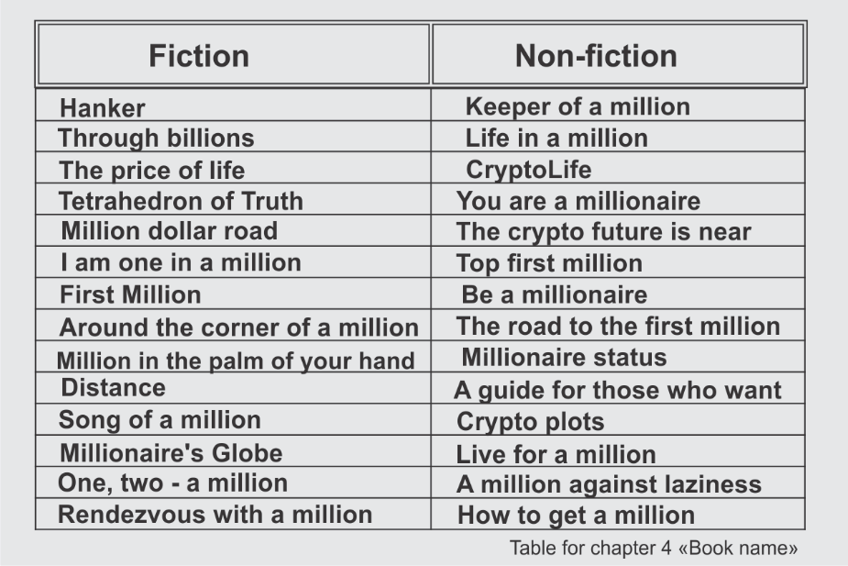
The headline allows the reader to immediately understand what awaits him. The book, of course, can have abstract, but attractive title. The designer's presentation of the title, for example, with English letters or inverted letters, may resonate in the "original" reader. Although from an artistic point of view, it can also be justified.
Expect your book to be easy to find on the Internet. Therefore, do not be lazy and search in systems such as google for invented name to avoid "double names" and other confusion. Always try to avoid ambiguity! Thus, turning to the titles listed above, we find out that the name "You are a millionaire" already exists (the book of an experienced businessman A. Goldenberg), as well as the book with the same name by Jay Liebold. The same in the case of the recurring title of the book "Love for Three Millions" (O. Khmelnitskaya). In addition, a reference (hint) to the famous work of Carlo Gozzi "The Love for Three Oranges" or "The Love for Three Zuckerbrins" by Pelevin more likely sets off a negative reaction to your work among readers due to the title similarity at first approach to the book.
Practice shows that during the period of writing a book, the title can change, sometimes beyond recognition. Hence, you can designate the name as "working title".
The title is necessary to guide clearly the idea of ​​your book.
An analysis of literary names used since ancient times led me to the following conclusions: it is already difficult to bring a modern name even with two directly dependent words, since you will surely find something similar in the history of literature. However, you are the unique one, so prolong yourself, and bring this uniqueness in the name.
The title should not only reflect the essence of the book, but also carry out tacit communication with the reader. A reader of thousands of books should be willing to take yours. Moreover, its name, its "face" should make the reader want to know this name. This is the moment where you should think about your reader. First, think about how the reader will see you.
Therefore, the very presentation of ​​the author can sometimes play a cruel joke. The euphony of a name in a public space is essential. Also, within the area of your book distribution, your name can shine brightly or fade.
The combination of first name, last name and title also affects the image. Therefore, authors use aliased names to separate true person from creative one. There are some cultural gaps in it. So you should take into account the semantic component of the combination of the name, surname and title of the book.
Disappointing conclusions follow examples:
Lev Bublikov "Philosophy of Time"
Anastasia Klepkina "Kings of Science"
Cleopatra Revina "Special Forces"
Our modernity also dictates a kind of depersonalization. The author becomes less interesting and important than the information he carries.
The part that concerns the information "about the author" should briefly, sharply, in one or two sentences convey the essence of your author's face. It is not really a biography, but some biographical information is required.
The biography will have to be submitted more than once and from different perspectives. So take the time to describe briefly your biography:
- your short biography (1st option)
- Now cut the text in half (2nd option):
It should not include information how and when you went to first grade or college. It should be meaningful information about you.
One student, pondering his short biography for several days, wrote the following: "I have lived and I live, and I will live." I feel how he was touched by the topic of biography, as at his young age he felt that nothing seemed to have been done yet. However, everyone was born somewhere, and, probably, everyone has a fact in biography that prompted him to writing a book. Name only a few who have already received several creative injections in the form of courses, schools, workshops.
As for the reader it is more important not to know "who are you?", but "what are you like?" The side of your spirit world is the connection between you and the cosmos. Going on talking about the informational purpose of the book and the formation of the title, keep in mind that modern publishing houses, acquiring rights from the author, promote not the author himself, but his work. It is less important "who you are", but "what you are like" and "what have you done." It is time for one more question. Reply:
What are you like?
This question will take you to the next step in creating your book. It will help you turn the page with the title, but you need to find out what you possess, to be of interest to the reader.

Chapter 5. THE TARGET AUDIENCE
Let us tackle reader perception issues today. I already foresee your indignant fidgeting - "it is the fifth chapter, and we have not yet written a single line of the book itself." First, there is already the first sentence with the desire you recorded. Second, where did you see the building built without a drawing, without a model, without calculations? You can used clay to build an earthen hut in one night. But soon the roof over your head will start leaking and the tightness will burn your stifling sensations of life. Therefore, as a professional tailor or a high-class architect, we measure, cut, draw, and sharpen. Now it is much more important to understand for whom you are writing a book.
So, the target audience.
The target audience for your unwritten book should be identified before starting master records and then kept in mind while writing. Moreover, just with your audience, you must learn to carry on a dialogue. They are the ones you direct your experience to. You retell your story to them. After publishing the book, you will expect their reviews and feedback.
At the very point metaphysical laws come into force: the book still is not exist, but you purposefully think about it, making room in the space of energies for its existence. You surround it with all the necessary attributes: readers, its appearance among professionals (logline, annotation, synopsis, which we will talk about later), appearance (cover).
You need to understand – why will the book be of interest to your audience? Look for the answer to this question.
- who is your target audience?
- write a portrait of your target audience:
- why will the book be of interest to your readers?
Writing down what could appeal in my novel for teenagers "Muleta for violin", I had to remember anyone interested in this book. Then I had to choose according to the majority principle. It looked like this (I have to notice that this is only the second part of my reflections on the target audience; the first part was lost somewhere in the archives of thousands of folders). By the way, be sure you to put all the necessary materials into one folder immediately. If you use napkins or perhaps toilet paper for your handwriting, adapt the cherished chest for them. It is a joke, of course, but who knows, "in what rubbish poetry is born ...»
This is how I saw the audience for my book
"Muleta for Violin":
The book does not impose on adolescents, but tells and shows the life of your environment, your peers. Similar events can happen to you, because you want to see yourself and your friends from the outside and find out who your real friend is and why it happens. The book also talks about love, the first true love, and falling in love, which makes you make mistakes and makes your life not what you dreamed it would be. Segments:
Teenagers 12-14 years old
Teenagers 15-16 years old

School graduates
Curious adolescents from the middle and wealthy stratum, who are interested in reading what is "not yet possible." The book has a rating 16+.
For school graduates, on the threshold of big life, everyone wants to become someone, one has already calculated his life for a hundred years ahead, and the other has not started yet. The book "Muleta for a Violin" can become a defining factor in your adult life; it includes all human virtues and qualities: the more you find them, the more confident you will be able to enter life. This book will warn you and treats many subjects.
Parents of teenagers - if you became parents consciously, then perhaps this book is not for you - you have already known everything by yourself. Otherwise, look again at yourself from outside. Do not assume that being an adult you take any step correctly. This book tells how to become a friend to your offspring, how to live your life so that every evening ends in a good mood for everyone. Then life will consist from the evenings. And it has a tendency to end too.
Teachers - it has long been known that teachers are divided into teachers and subjecter-устаревшее может educator? Subjecters are up the eyes in work, everyday life, lessons for them are source of income. A teacher is quite different from a subjecter. He teaches not only the subject, but also the path of life. Years of changes at the end of the twentieth century have presented a whole galaxy of subjecter, so more and more often you can meet from students a negative attitude towards their professors. The book does not reflect, does not preach, it shows the difference in the paths of a teacher and an educator.
For grandmothers with grandchildren, you can reach their understanding of the world through your love to grandchildren. You have chance to adjust your parenting, so why not take advantage of that. "Muleta for Violin" has many different things you can discuss, giving examples from your life.
For fathers who are businessmen - while family providing you can sometimes miss something very important, in round-the-clock work. You take no notice of your son’s first steps, his school days, his full age. These are milestones. However, between them is life with the daily father and son gaze, with a thrown or heard word. "Muleta for Violin" tells about the family of a businessman who just in time looked over his son and understood not his whim, but his feelings. Learn to feel together with "Muleta".
Mothers-housewives - modern mothers-housewives have already retrained into active lovers of culture and art. They take courses for coaches, artists, etc. So, the recognition of the life of their growing child is more understandable for them than for husbands, who are often absent due to the work. "Muleta ..." will tell you how not to lose what is not yet lost, how to return what has already been lost. In reading and discussing the actions of the characters, a lot will become clear in your life.
Working single mothers - Rush, temporary time pressure, provision of amenities is the burden that still fall on the woman. "Don’t say that! Do you really think I can find the time?! I want to sleep and you advice to read a book!" However, you must stop before it's too late. Before the worst happened. Make it a rule to spend the evening with the child, reading, perhaps discussing, for example, "Muleta for violin".
It will be interesting to read about adolescent love for those who are still 11 years old. But only - shhh! – keep it in secret from adults ... It will be possible to discuss it with them later, when you grow up.
For school principals and head teachers - A system, a set of rules, a pile of completed documents can never become a counterbalance to life. It includes movement, the search for the life meaning, increased crime, scheduled meetings, swearing on carpets and at a general meeting, conflicts with students, parents, pressure from above and plans-plans... All human virtues are represented in the novel. A few lives will not be enough to apply each one to yourself -. Careful reading can replace this real-world experience. Read it and discuss with teachers and students.
For professional musicians - the story of a musical surname, described in the novel "Muleta for Violin", dates back to the time of Catherine II. The whole book is saturated with music. Her sounds come from the violin, from the classics of Vivaldi, Bizet. From the music of illusions, inspired by the image of a bullfighter waving a muleta in front of an angry bull, just like life that teases and beckons to bright light, but then unfairly hurts.
For bards - the connection with the guitar song in the novel "Muleta for Violin" appears occasionally, in an episode with the bard's festival to which the whole class with the teacher and two parents go. What can a worthy song do to a soul? It can balance harmonize it. After all, the purpose of sound is to deliver aesthetic pleasure. The level of people aesthetics depends on many factors - on education, upbringing, worldview. The aesthetics of a real bardic song is not three chords, it is the music of the spheres, the music of life with the conclusions that are plain to see.
For psychologists, trainers, cultural scientists - the themes of relationships in literature were used for the development of psychoanalytic processes as early as the 60s. Is the whole sphere of relations plowed up? Individual psychology, the psychology of interpersonal relationships in groups, cognitive dissonance, revaluation of values, the formation of ideas and the somatic of emotional reactions - all of this “Muleta for Violin” presents in sufficient volume. Vertical and horizontal parallels give a big picture not only of the adolescent world. The author of the novel also touched upon a wide range of human virtues and vices. The author also dares to assert the presence of suggestive meanings in the text.
For school teachers - all the most precious things that were associated with school years are reflected in the novel "Muleta for Violin". It is not an autobiographical novel, but fiction based on collective personal experience. Each character hints at the past - in names, gestures, actions. There is also music, love to which my dear teachers have also rewarded me.
For schoolchildren and students - the author of the novel was also once a teenager. I sat for almost all school years, invariably in the first row, at the penultimate desk, closer to the aisle, and my friend sat by the window. The novel does not have my prototype, just as there are no prototypes of my other acquaintances. But there are features, views, names of dear people. The novel does not teach, it tells one of the stories in which human strengths and weaknesses are gathered. I would be glad upon arrival at my home school to meet with you as readers of the books where our interests cross over.
For my classmates, we were different. I remember my parents repeating this phrase concerning my generation. Now I am sure that our grandchildren will repeat the same to their children. You see, we are still the same. Both our problems and our questions are the same perhaps with a slightly different color, different technical attributes. However, no technique can affect human relationships and those qualities that were formed by Aristotle. We are not different. It is just that our life is already going downhill, and all the attention is paid to our successors. I dedicate this novel to my generation, no matter what. This is for you.
Creative people - in creativity there is no place for looking back, because a powerful force drives it. It is the wheel, which at first tightly pushes the top layer of the earth while you roll this cart up. And having been rolled up the top, it goes downhill by itself at a breakneck speed. Creative people you can understand me. I wish you be healthy and the opportunity to have a proper person beside you. Perhaps this is exactly what the novel "Muleta for Violin" was written about.
So:
- why will your book be of interest to your target audience?
- why will your audience be interested particularly in your book, and not a thousand others on the same topic?
And finally:
- what important decision, conclusions can your target audience make thanks to your book?
Place yourself in the position of your book reader. Look at the content through the eyes of those whom you dedicated your inventions. Using the answers to all the posed questions, you will create a portrait of your audience.
Admire the features, traits of your target audience. Learn to anticipate those who will not be interested in it. Describe it as if it is your dearest person who you trust your views. Thus, you pave the way to your reader, determine the degree of trust to him, clear the field for your own thoughts, open the way for your book.
Family or single people, women and men, their age, character, education, profession, habits, desires - let everything be mentioned while describing.
The book will be of interest to people who you describe with interest, thus attracting them into your circle.
- so your target audience:


Chapter 6. CHARACTER. CRITICISM
Your "talented readers" your critics are special people in your environment. They should also be included in your audience of interests. Thanks to criticism, your book can be picked up and advertised. A united institution of criticism has no long existed. But their presence is like a secret order, a community which keeps watching and pronounces its sentence.
My specialization at the Faculty of Philology is criticism. I am grateful to my teachers, who recognized my ability to think thoroughly. To be honest, many of my reviews have been rigorous. However, I made it a rule for the term of my life: a critic is not the one who severely criticizes, tears down, reduces to dust or destroys... The critic analyzes and shows the way. The critic creates and refers to perfection. There are other institutions for destruction other than criticism.
The critic helps to improve the work. He notices weak points that the author himself may miss. Therefore, do not be afraid to give your work for review, entrust it to the critic analysis.
In the title of this chapter, I have purposely combined two at first sight different terms "character and criticism". You pacify your character with virtues and through criticism learn to listen not only to your inner cry, but achieve consent with the world, with the context of life, not only around you. While describing other characters in the work, you need to start with yourself.
The material I have collected in the table "Virtuous traits and vices" can be of help in this description. The table will suggest your character personality. But your task as a writer is not only to name character traits, but to show the way they developed. This table is based on the works of ancient philosophers, especially on the treatises of Aristotle (384 - 322 BC). Over time, many of the traits of human characters have undergone changes. But it was non impacted as the whole but only some nuances. Therefore, while working on the creation of this work, I had to explore these aspects of human nature. The study lasted more than twenty years. The path to each virtue or vice proved to be multifaceted, so anyone who walks the Path is sure to find what they are looking for.
The table can be found in the "CHECKLISTS" section, in the second section of the book . The table is in two parts, each with two columns. The first part includes the virtuous qualities of man and their descriptions, and in the second part the vices indicated are also connected with a list of descriptions. The listed features are extreme in terms of the scale of the relationship. Between forgiveness and revenge runs a whole road of anger, hatred, indignation, annoyance, irritation, revenge, insult, rebellion, resistance, envy. Feelings mixed with emotionality will help to create a general picture of understanding yourself, your scenario of life and, of course, your heroes.
But do not rush to conclusions about yourself, and even more so do not despair if your script seems "not very good", and even more if you consider yourself as a "bad guy."
Only a higher reason can adjust your life scenario. The person next to you only presumes, as, by the way, you as well can presume only subjectively. Remember one more subtlety: for a writer, an important quality is the breadth of his perception of the world. The good man is boring, as an absolute scoundrel annoys.
So, after being acquainted with the list of virtues and vices, answer the question again:
- what is your character? (Pay attention, this is the third time you have to answer the same question - think why it is necessary).


Chapter 7. ANNOTATION
The book is accessible not only through the title. The reader often wants to know the essence of the work before a desire to immerse himself in reading. Annotation can contribute to this.
An abstract is a concise summary of a book designed to grab the attention of a reader, critic, producer, or publisher. Another name for annotation is hook. It is a kind of advertisement, which lets judge the offered content. The annotation contains the reader's expectations about the type of your material. The reader, through the annotation, dispose to the author's promise to provide him with the necessary information. Therefore, negligence in writing the annotation can have negative impression on the reader.
The abstract is placed at the exit of the book with duplication on the back of the cover.
There is also another name for annotation - logline. But it is more directed towards a dramatic work, although its essence remains the same.
The total length of the abstract should not exceed one or two sentences of fifteen to twenty words, excluding prepositions and conjunctions. A sentence before the annotation, beyond the mentioned number of words, should contain information about an author, indicating the first and last name, and the work details such as the title, place and time of writing, the publication.
You can say - it is difficult to write an annotation for the entire work briefly. While there is no work the work itself.
Nevertheless, this is possible if you follow the scheme:
"WHO - DOES WHAT - FOR WHAT PURPOSES"
The summary of the abstract lays the entire book meaning in close-up, as if under a magnifying glass.
The annotation written by you will stand a good stead to you a whole bunch of times. You can use it in the imprint of the book, in the so-called circulation of the publishing house, on the website, on the cover, in advertising brochures. It will help you quickly answer the question “what is your book about”.
In the annotation, the general concept should relate to the character / characters in the book. It includes conventionally ciphered meaning of the protagonist appearance, and the consequent, the desire of the protagonist, for the sake of which this book was written, i.e. "What is the point?"
Remember that in the eyes of the audience of readers and in the eyes of the publisher, the abstract looks completely different.
It is important for the reader to grasp the essence of the work through the annotation and superimpose it on his own interest: will it be interesting and fascinating to read?
Slightly different aspects will be important for the publisher and producer, which, of course, depend on many nuances. Someone will look at the topic intensity, shining through the annotation, at its relevance, at the professionalism, and even at the style.
Therefore, in its presentation you should look for golden mean.
The annotations should not go into details, you need to keep the intrigue. At the same time, you should keep the integrity of the story talking exclusively about the plot. The author's image should not be woven into the annotation.
Annotation shows the problem the protagonist faced.
Accordingly, it is necessary to describe the main problem the main character solves in the draft.
So describe the central problem of your book by answering the question:
- What is the core issue the main character solves in the course of your book, and, possibly, might solve?

WHO - WHAT - FOR WHAT PURPOSE?
You can create a draft annotation sentence in another way, starting as follows:
This story is about ... and then indicate the gender, age, artistic image of the protagonist, which will be the answer to the question "WHO?":
"What did he want to do?" Then show the goal which achievement is clear not only to you as the author, but also to the reader and the publisher - "WHAT?":
"What is the point? What should be the result?" – For what purpose he needs to do something...
For example: on the way to his goal, he collides with ... or do such and such things worthy the reader's attention, necessarily implicating some overcoming.
Notice (!!!) Make sure you indicate the first plot twist that caused something to happen ... (here you describe the result of the collision):
... either he did not succeed at all, or it turns out that from the very beginning everything was completely different from what the readers might have guessed.
If you cannot write an annotation, then it is not about it, but about your story. It means that you have not thought out the story yet. In this case, go back to the first pages of the book and once again think through the answers to all the questions. Then come back here again.
A good annotation has four key elements:
- the main character that is the protagonist
- "bad guy" or obstacle that is an antagonist, or antagonists
- conflict - that is, what stops the hero
- ending - that is, what will happen
Use irony when writing annotations! With intrigue and curiosity, it attracts the reader and the publisher with the question "what will happen next?"
When writing your annotation, keep the main idea in mind, as if you are about to discover a sensation. Do not reveal it completely. At the same time, let the reader feel the taste, smell, volume, color of your sensation.
I advise you to read the written annotation every day before starting work on a book. It is like revising "whether you write properly".
I give some tips on writing annotations.
Is this a book about a person or his deeds?
If about a person, then about what person?


Describe main quality in his value system, not personal, but the main moral quality he aspire in this book:
Who is opposed to all this?
Answering these leading questions, you should form an understanding of the main thing that should happen to your hero, for the sake of which this whole story is writing. Describe why you create this story:
If this is a work of art, your story has a purpose to transform the qualities of a person.
If it is non-fiction, this "main thing" is unlikely to become a person, or yourself. Man is only one unit. Yes, a lot depends on him. However, he exists, like a chemical element, in compounds, interactions. Perhaps he manages to isolate himself from the environment influences. I do not consider withdrawal. It is some external force. What is this? Is it passion to his work, experience gained, or professional interests?
Suppose you are one of the students who is writing a utopian book about human nature. In "annotation", in this case, we must touch the questions that will lead the reader to conclusions about what kind of person can a man be, whether the nature needs him, what is his role in the universe system.
I will begin my discussion of a utopian book with two theses. Designate the promoted idea with theses. The thesis is the starting point that requires proof.
The first thesis will outline the conflict declaring that “Man is not important for nature”.
The second thesis - "It is important what a person leaves behind."
Let us say your main character tries to make people happy, it is his mission. At all times, the search for happiness has been an obstacle. It becomes impossible to be happy absolutely when there is an ineradicable misfortune, devastation, wars, authorities, diseases, and rotten environment on Earth. Therefore, in search of happiness, the main character begins to "build a spaceship like Noah or Elon Musk. Why is he doing this? He wants to create his own value system, with freedom as the leading quality. It is not the freedom of anarchy, but the freedom of a person who acquires knowledge as food, capable of performing complex tasks of the world order, creating robots that serve humans. In the center of the main character's system of values ​​is the wheel of Samsara. But not it its religious meaning since religion limits, fetters the actions of a person, and subordinates. The hero gets a tarot card "Wheel of Fortune". However, is it worth trusting the main character? Although he is born into a family where balance and love prevails, he observe different things around, in the yard, at school, among his friends. What religion and philosophy will he choose? How, will his worldview form? First, our hero will start protesting submission, and what will happen next?
Thus, he will gradually build a new human community, based on the mixture of Roman law, and the leading pedagogical thought, and the aesthetics of perfection.
The striving for the absolute at all times has been the innermost desire of human thought. But do we have any examples of approaching the goal? Who will the main character meet on his way? Perhaps some wise men, seers, scientists of different times will visit him in dreams. They must be iconic personalities.
They all point to the transience of time as the only reason for the inaccessibility of the target goal. If the main character begins to expand the space, he will come to vague conclusions. What are the conclusions?
Further on, I would advise my student to read the book by Vladimir Makanin "Where the sky meets the hills", discussing the position of the protagonist through the idea of ​​the book.
For V. Makanin, the idea of ​​the perfection of the world lies on the surface of the story. Its essence is in music. Grigory Bashilov's ears caught the slightest falsity. Having heard this lie, he wanted to turn the world away from it, change it, but did not know how. He closed the world on himself.
The hero of your book should differ by the fact that he knows how to change the world and changes it (or makes an attempt?). Along the way, he meets an avalanche of resistance. This resistance is the antagonist of our hero.
So, I would advise you to formulate the annotation for the book on the search for happiness as follows:
This book is about the freedom of a person who fights against a system of stereotypes, constructs and prepares for launch a model of a new planet full of happiness, without returning to the past.
WHO: This book (1) is about freedom (2) of man (3),
WHAT DOES: that he regains (4-5) from the system (6) stereotypes (7),
FOR PURPOSES: designing and preparing (8-9) for the launch (10) of a model of a new planet (11-13), full (14) of happiness (15), without returning (16) to the past (17).
Now you can sharpen every part of the annotation sentence by thinking, squeezing, changing words and even meanings. At the end of the day, you need to bring that wording to a comfortable reading, not as sublime, as it turned out.
For example. We used the definition "about freedom" in the main thesis - but, on second thought, it may turn out that freedom will not become the main indicator in the thesis, as the main character does not strive for it. Why? What could be the main character's goal? Maybe it is Search? Then by the end of the book, the action will remain incomplete and give no result, because the search is just an action aimed at a solution. Thus, we still need to find a way out, a solution.
Here is the example of work with each annotation phrase.
The more you delve into this formulation, the wider the gates of your book will open.
Your experience of working on annotation will still come in handy. First of all while writing of a synopsis. You will learn what a "synopsis" is, as well as "plot" and "storylines" in the following chapters.

Chapter 8. SYNOPSIS. PLOT. STORY LINE. LEITMOTIf
A synopsis is a professional summary of a work for presentation and review to major publishers and producers.
Also, the synopsis will help the illustrator complete the work on creating the cover of your book, and, if necessary, on the illustrations inside it.
The synopsis summarizes the data about the target audience, as well as about the author. A brief and chapter-by-chapter material of the book is given in the text preceding the synopsis. Sometimes the synopsis is presented in artistic form, without a sequential description of each chapter. Formal synopsis text with dry data will never attract attention of the publisher or the producer. Therefore, similar to the abstract, it is necessary to use the rules of the advertising text. It must be bright, but not pathetic, thrilling, succinct and teasing.
While presenting the synopsis of The Lost Name, I first described the events in sequence, assuming that in this way I could convey the content.
Nevertheless, in the process of recording the logline chapter by chapter, I formed the text into two quotes:
“Mikael, on assignment from the American Research Institute, is sent to Siberia, where he must meet with a contact and pass important information to him. He flies through Vladivostok, where some scammers robbed him near the airport. In a semi-conscious state, having lost his memory, Mikael gets to people who are ready to help him. Vera, falling in love with Mikael, persuades him to stay with her, but Mikael needs to regain his memory. He travels to Buryatia to see the spirit of Lama Itigelov, hoping that this will help him regain his memory. The train conductor gives a fleeting piece of advice, which is the key to bringing back Mikael's memory. From the abandoned half-station, Mikael's paths lead to unknown places, where he meets the healer Alaya and her monk son. The harsh winter, illnesses, immersion in the monastic life, Alaya's healing conversations bring back the memory. And again the road is waiting for him...
A parallel part of the novel concerns the Gardener, to whom Mikael was supposed to come. Thirty years of life in a Siberian village have gain him a great confidence of his fellow villagers. Maria, the saleswoman of the village shop is in love with him. The mayor of the district is jealous to the Gardener, trying to use him for his own purposes. He realizes that the Gardener can compete with the mayor in the elections. The life of the village unfolds through vivid images of the director of the house of culture Nadezhda, the local drunkard and poet Monya and others. But the Gardener is waiting for a meeting with a contact ... ".
Such, I would say, the initial text of the synopsis was compiled "for myself" in order to present the work to an outsider's eye.
However, for myself, a plot was written down action by each action.
As you can see, first the events take place around one character - Mikael, and then around the second character - the Gardener. The events develop in parallel.
These two characters and the events around them are the two axes of the work. The axis of the work is the storyline.
A parallel part of the novel concerns the Gardener, to whom Mikael was supposed to come...
So the primitive text of the synopsis was compiled "for oneself" in order to deduce the plot lines of the work.
The storyline is the central axis of the work, around which the main events unfold. As a rule, a story (small literary form) contains one storyline. There may be more than one in a novel.
Let us now clarify what a "plot" is.
The word "plot" is translated from French as "object". The plot is the central node that forms the events of the work. Events strung on the storyline, developing and extending it.
Consider examples of plots and storylines.
In the Russian folk tale "Kolobok", the main character from birth to death consistently passes from one event to another. The character of the hero does not change, since Kolobok purposefully implements his idea having escaped from his grandparents, just go "wherever its eyes look" and sings its song to everyone he meets. The whole plot can be put in a few verbs: was born - ran away - sang his song to those he met - died absurdly.
But we are now talking about the storyline in this case it is straightforward.
The story of the protagonist is always in the center of the storyline.
Let us consider the geometric function of the line, as a figure that has a beginning and an end. For example, imagine an ordinary ribbon. What can you do with it, except to put it right in front of you? Anything! We fold it in half, twist it, tie it in a knot, tie the ends the same way we form the direction of events.
In the same straightforward manner, the storyline develops in another Russian fairy tale by A. S. Pushkin, The Tale of the Fisherman and the Fish.
The plot of Pushkin's fairy tale is based on three characters: an old fisherman, his wife and a goldfish. The very beginning of the tale plunges the heroes into the everyday life, where the fisherman is the central figure. Every day he goes to sea in a search of provision for his small family. One day (it is the main word in the turn of any plot!) A goldfish comes across in his net. The fish in this case is the personification of good luck, which the old man deserved with his hard work. The events begin to clearly manifest themselves and develop around no longer a fisherman, not a fish, but his wife (it is an interaction). It is she, who shows violent fantasy in her desires. It is she, who becomes the epicenter of the reader's attention. As for the fisherman, the reader begins gradually to feel sympathy to him, and soon to bleed for. Of course, the author manipulates the mind of the reader and clearly does not offense the old man directly. He puts in the mouth of the old woman monikers "a gawk, a gaper." At last, the major “heroes” moral categories such as “what is good and what is bad” enter the “stage”. Since this is a fairy tale, the feelings of the characters are exaggerated and clearly drawn. With each turn of the plot (one plot!) the growing human vices accrue dramatically spreading from the “transformations” of the old woman onto her environment, which in turn delivers the main culminating verdict “let the cobbler stick to his last”. The plot, having made curtsey to the fisherman ends at the point the fairy tale began. This technique has a definition - a circle frame, and at the same time, that means a circle plot frame: we returned to the point we left. The figure of the ribbon in our imagination turned into a circle.
Increasing events feed the storyline and, as a result, are resolved by the loss of luck, which both came to the fisherman and left, “wagging its tail”.
Events in The Children of Captain Grant by J. Verne, in The Via by N.V. Gogol develop in the same linear way. In linear development, small excursions into the past or future, or, for example, into a dream, are acceptable - this is an excursion linearity. But if there are time gaps in the events of the plot, it is a so-called discrete, intermittent or dotted linearity.
Events can develop along a variety of trajectories: not only sequentially, but also inversely, or in a spiral, and in other ways.
However, if there are several storylines in a work, they can develop in parallel so we have a parallel linearity. It is exactly what happens in my novel The Lost Name.
The opposite of the linear way of presentation can be an inversion of the plot development, a kind of reverse course of events peculiar to criminal, investigative plots. At the beginning of such works, the shown incident unwinds through the events back to the starting point, to its cause.
Another type of plot development is concentric. When the central event was already indicated, for example, Chatsky arrived - “Woe from Wit” by A. Griboyedov, and then plot connections with other characters of the play began to stretch in different directions from Chatsky, like rays.
Events develop concentrically in "A Hero of Our Time" by M. Lermontov, as well as in "Crime and Punishment" by F. Dostoevsky.
What for the non-fiction genre where the hero and his antagonists are not indicated as brightly as in a work of art?
In non-fiction, there is only one storyline, and it pulls on the documentary story that you want to convey to the reader.
In the case of non-fiction, we will place the text in chronological order in the composition linearly - event by event, as they evolved historically. However, I suggest separating artistic paragraphs from journalistic material, i.e. describing something as personal impressions followed by business information (or in some other order). Then again, you talk about your experience, and again it is followed by part of the work with business advice. You can determine certain proportions yourself. It should be noted that absolute proportionality can harm the entire work. Do not allow yourself to be predictable. For an example, you can refer to the beginning of the book, which describes the mini-essay "Ice Cream". Surely, when you finished reading, you did not understand at once whether the story would be continued or not. I on purpose separated the texts of different styles (fiction and journalistic) in different fonts.
Closely related to the concept of "plot" is another literary term - "leitmotif".
The leitmotif of the work accompanies each storyline. It is like ornament on your ribbon, creates a line pattern.
The leitmotif of the story about the fisherman and the fish, its prevailing mood, the main emotion, the leading idea will be human greed, which led to dissatisfaction with life, pretention, ingratitude, arrogance and selfishness of the old woman. But tolerance, generosity and innocence of the main character, a fisherman, quietly settled nearby. These ambivalent relations led to the conflict. The fish here acts as a judge, inflating these overdue relations between the characters.
Leo Tolstoy's Anna Karenina, for example, is depicted in several conflicts cutting through and creating storylines in the fates of two families: Anna and the Vronsky, Levin and Kitty. The events of the novel compositionally lead the reader to the solution of some moral, public opinion and philosophical issues. This is the leitmotif of the piece. There are two storylines in the novel, they intertwine, and each has its own conflict.
Leitmotifs form the basis of the work, reflecting the writer's views and shaping the reader's taste. If we compare a work with a grape, then its seeds are storylines, the pulp framing them is events, that is, the plot itself, and the juice of the pulp is the leitmotif.
The leitmotifs of the characters lead to the leitmotif of the whole work. These can be small details of one big component of the hero's character, such as: speech pattern, appearance, behavior, interactions.
For an example of explaining “a leitmotif”, we can use connection with music. A musical leitmotif relies on a certain tonality and its transitions to other ones according to the laws of harmony. Thus, revealing the general idea of ​​the work, you, as the author, cannot pull out fast and furious more and more new characters if they are able to draw all the attention and lead away from the main plot. A leitmotif is a canvas that fills the plot with the juices of one flavor bouquet.
In this chapter, you learnt two new words "styles" and "composition." We will talk about composition on the following pages and about styles a bit later.
In the meantime, describe the storyline of your book:


Chapter 9. COMPOSITION. STRUCTURE OF THE BOOK
Composition, the construction of a work has its own laws, just as the construction of a building. It begins, as we have already said, with planning and calculations. A simple rule comes into force: spend some time on calculations, preparation, and you will learn first-hand how quickly your work can be created. That is why we have spent so much time preparing the writing, so that you already know: what is the name of your book, who is its main character, what will your book be about, what will you offer the reader in it. Now we come to the question "how" to shape the material.
Compositional construction includes the idea of ​​dividing a work or an entire book into its component parts.
Let us talk about the possible number of parts.
The classical form consists of three parts as you probably remember from your school essays. Such structure of "introduction, main body, conclusion" is a little outdated. However, pay attention at the uneven number of parts. Even forms are not involved due to an unspoken rule. They tend to absorb, close on themselves. Oddity creates the so-called "interference", which correlates with unevenness, vividness, and conclusions. The five-part form is quite convenient. American cinema uses seven-part or nine-part forms. Some cinematographers of the late 20th and early 21st centuries write about this, for example Robert McKee.
At the very beginning of work on a book in the non-fiction genre, make a sketch specifying episodes you would not like to leave out of account. For example, you decided that you would definitely write about childhood, the period of growing up, the first business experience, mistakes analysis, about attitudes, the stage of enlightenment, about wealth and poverty, about world trends, about dreams, view system, travel. Rank them in ascending order of importance. Divide all these topics now, at your discretion, into three parts, or five, or seven. The first part is certainly an introduction of the whole book. The main events in their development are in the center. The last part is an epilogue or conclusions. If you feel too cramped while placing the material in three parts, then move away from this tightness into a five-part form.
What is the main thing in understanding the use of knowledge about composition? Just at that point, the writer shows his concern about the reader. A continuous, indivisible text is difficult to understand for an unprepared reader. However, if you count on a certain category of readers, you do not have to worry. Show your imagination, invest yourself the way you are. Just remember that you still have to look for “your” reader.
We had better talk about mass culture, about the principles of reader's perception here. But this book is not about that.
It is time for us to imagine the full scope of your book and connect it with the compositional construction. Let us say you end up with 250 A-5 pages. By the way, publishing houses pay attention at the number of characters (symbols) not at the number of pages. You do not need to count them manually. You can find automatic calculation in the Word program in the "Overview / Statistics" section.
The number of characters are counted with spaces. Approximately one A-5 page in Arial font, size (font size) 11, single line space contains 1800 characters including spaces. But we need one and a half line space - 1.5 points.
While working with a draft file, it is better to use A4 format. Please send the manuscript to the publisher in this format. You should not decorate pages with different fonts, “discharge” the text or use intricate font. If you want the text in the book to look somehow unusual, you can write an explanatory note to the publisher for the designer about it. But only after your text has been accepted for production. At the stage of acquaintance with the text, the publisher is not interested in external decorations, but in the material itself.
One page of A4 format (single line space) tightly accommodates up to 3300 characters. However, it is better to use one and a half intervals from the very beginning, and such content will hold up to 2300 characters.
Approximately 100 A4 pages converted into an A5 book on medium weight paper will look like a small booklet with a spine up to about 1 cm.
Now let us apply to some simple math. Let us say you set out to write 200 pages of A4 text. If you are going to write a book in 3 months, then every week you need to prescribe about 17 pages.
Make it a rule to write every morning and every evening. You may also make a voice recording, and in your free time convert these audio files into text. If you run webinars, then 50 minutes of your continuous speech can result in 40,000 characters, i.e. in one author's sheet, or about 20 A4 pages.
For each part, (if it is a five-part form) you will need about 38 pages in the rough because the volume of pages required for printing a book includes title pages and pages with content and imprint, lines of chapters. It gives about minus seven pages in total including or excluding pages with illustrations, tables, if any. Keep in mind that parts will not be equal in volume. Roughly, you will have approximately five chapters in each part. So, we leave 6-8 pages for each chapter. Keep in mind some reduction or expansion while editing the style.
Your task is to briefly describe the 5 parts of your book “what each part is about”:

I part of the book

II part of the book

III part of the book

IV part of the book

V part of the book
Then take the time to write brief "details" for the chapters of each part. The synopsis you have already written will help you.
The word "details" is in quotation marks, since all these "details" should fit, like the text of the abstract, into 20 words. Introduce the professional reader to what happens in each chapter in a teasing way.
After writing all the chapters, you will have a synopsis ready. While describing the events of the chapters, do not forget about intrigue. Capacious content should hit the top ten (well, at least nine, but not "off the mark"). Therefore, intrigues, intrigues and once again intrigues. After all, each chapter should end as if to be continued. Keep the interest of the reader on a constant hook, on a short leash. Remember that now your reader is a professional so no flirting, and at the same time, continue to generate interest.
After you have described all the chapters, and have about 25 chapters in total, you need to expand the main thesis to one paragraph.
Each paragraph has five sentences: one for an introduction, the next three for each event, the fifth is an ending with intrigue.
In total, a three-part book should contain at least three conflicts (one main and two minor), a five-part book five respectively. The development of all conflicts will take up to three-quarters of the book.
Well, we meet another new word a conflict. We will talk about it in the next chapter.

Chapter 10. CONFLICTS
We're all different, aren't we? For one, a quick glance is enough to understand what's going on; for another, a whole bouquet of feelings is needed. And some even need to grow this bouquet themselves, using the simple principle of consistency: to grow something, you need to sow it. And so the third type of author will need a period of growing sensations, moods, emotions. For any type of story, you must become a sponge, a "walking piggy bank," absorbing the observations of the general public. Something you are uncomfortable with, something may cause a violent reaction, while your opponent may remain calm. By investing these states in yourself, by thinking about them, you will not be able to avoid an inner transformation. You will no longer be able to remain the same while experiencing this or that profound event. You will come out of that event reflecting on yourself. So there is bound to be some kind of renewal or even reboot, so that you are bound to become a new person.
The same chain of processes must be present in your character. Any character in any work must go through a transformation, a renewal, or, in literary terms, a metamorphosis. However, it is not enough to describe the character or his/her appearance along the way. You must place your character in circumstances where he or she will manifest himself or herself through his or her actions, and the reader will draw his or her own conclusions. Almost all transformations have some risk or pain to experience. Only with experience a person does change. The answer to the question “Is it possible to change without the pain? As for my harsh opinion the answer is negative. A painless exit is equal to your usual, common state. It looks like a public lie everyone around agrees with. If no one protests against this lie, then the situation is not resolved, it is stalling. A work, including a scientific one, is written in order to identify pain points, to reveal and resolve them. That is why adventures are much more exciting than philosophic musings. The pain of empathy presents in both cases, but as for the adventure story it is on the surface, therefore it is more accessible, more visible. As for philosophical comprehension, it occurs secretly and only for those who are already ready for these transformations.
Answer the question: what painful points do you highlight with your work?
While answering, you can use the checklist "Virtuous traits and vices."
And, of course, answer the question:
What do you think pain is?

This is the very annoying moment when in the clash of the parties something dies, and something is born in this place. The new one always replaces the old one. In the Chinese philosophy of military art, the meaning of the development of the whole creation is expressed by the phrase "what has once risen must fall." Even the alteration of night and day is one of the sides of the pain. Pain, if you will, is a reaction to conflict.
Conflict-free existence is "nothing".
The main goal of any book is a path to transformation, to obtaining new information or to a different interpretation of the available one. This transformation is impossible without identifying the point of conflict. The brighter is the conflict in its general cultural purpose, the more significant problems it solves.
Remember the golden rule: no conflict, no work. If suddenly there is no conflict in the work, then the conflict will arise between the author and the reader.
Conflict is the driving force behind ups and downs. Ups and downs are turning points in work.
You can ask what kind of conflict can present in non-fiction.
To answer this question let me first ask you a question in turn:
Do you remember a parabola function from Geometry lessons?
Almost all the events of our life are like a parabola. Its overcoming is necessary in order to reach the highest point of the axis of symmetry of the parabola, its top. However, according to the laws of physics, after passing this point, a decline is inevitable. It happens both in life and in literature of various genres. The only difference is the axle height. In non-fiction works, the highest points of each chapter belong to the described essence with a plot, a development to its highest value, and after that with a decline, completion, summing up. A smooth, conflict-free description can create the same kind of conflict between the book and the reader. Even in non-fiction literature, there must be a conflict.
Let us talk more about the formation of the conflict.
The first subject to create conflict is your protagonist. The purpose of every book is to solve a problem. The protagonist is the central figure of this problem.
Who opposes your main character in your work?
I have summarized the answer to this question in a general description like this:
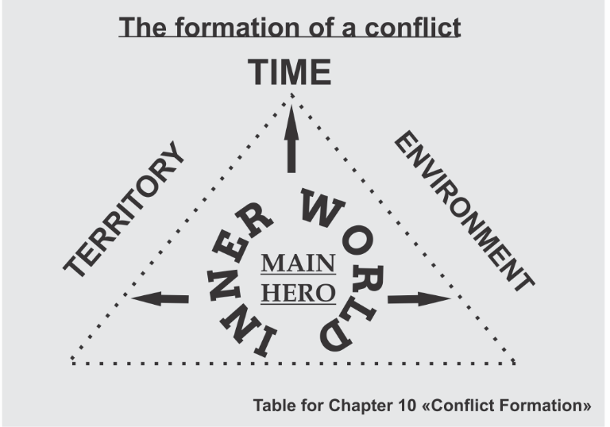
The antagonist (those who oppose the main character) may not necessarily be a specific person from the environment. It can be a time, a phenomenon or even a territory. A phenomenon or territory is also a “hero” that you have to deal with every day. Both the phenomenon and the territory have their own face, as a collected character. They contain certain views of you that may not coincide or even conflict with your views of the world. Your territory may not belong to you, or on the contrary, you may subjugate it and play with it like a puppeteer. The territory can be narrow or wide. It is even capable to conflict with other territories.
In addition to the territory and the phenomenon, time can be the basis of the conflict. When you point out a conflict with it, you should be aware that you may not become a winner, but it will aggravate the conflict even more.
In addition to territory and time, you can become the cause of the conflict, having come into conflict with yourself. This is perhaps the most difficult form of conflict, and you should solve it in fiction genre but instead of the non-fiction one. This is part of the phenomenon.
The most common cause of conflict in non-fiction is an event. Let us take a closer look at what you can call an event.
When you post a message on a social network about your day, you tell the world about yourself, your experiences, feelings, actions. Your "post" (I put the word in quotation marks, since the originality of its purpose cannot be replaced by any borrowings therefore, a term "letter" or, at least a "message" is closer to me) is your message to the world, your story about a past event. What is an event for you?
In the light of global and even local events of your particular country, your personal feelings about the day you lived may turn out to be insignificant. But they are significant for you personally, since in any event, the main things are conclusions, the results. An event without debriefing is a null event. Leaving no trace, it can do more harm than good. Take, for example, the most common event on social media — birthdays. For a man the birthdays is undoubtedly an event of lifetime. But a date itself with congratulations from your friends and relatives is an common event, unless you are a public, famous person. It is very important what is beyond the birthday celebration, what results you have had up the date, what are moral messages. It can become an information event, depending on the significance.
A common event can also become interesting if something happened in it.
Let us analyze the situation with a birthday and a description of this event. At what point in this event or its description can a conflict arise?
Traditionally, friends wish you success, fun, love and happiness. You got gifts. You agreed to eat out with your friends at a restaurant. You cannot call it an event. Even if you went on a trip on your birthday, it is also not an informational event, but just a foundation for it.
An event will occur if there is a clash of personal and public interests. It can lead to a conflict.
Undoubtedly, the conflict of the work of art is more vivid. We achieve it by focusing on the characters the protagonist conflicts with.
It is clear that the book will become a necessary, ideally a reference book for people (here and now), for humanity (after), if it answers the right questions. The right question is part of conflict resolution. Therefore, you must clearly formulate these questions. Conflicts in the book are not, as they say, "point-blank question." Some will sound immediately like answers, some in dialogues, and some in descriptions. However, they must be.
The book is the answer to your questions.
So the next step is to formulate those questions that you need:

Each question is like a problem that needs solution, so it is penetration into the conflict.
We have already indicated above that the cause of the conflict is an event. A clash of interests, a mismatch of worldviews are at the heart of the event. Therefore, each chapter must contain a conflict otherwise the story will fall apart. Once again, I remind you that if there is no conflict, there is no story!
Everything in our world is in harmony. And a man, despite the fact that he exalted himself above nature, designated himself a dominant is still a part of it. Moreover created like other mammals, we have distanced ourselves from the natural world through the ability to think. The mental processes that take place in the human brain are like natural disasters: windlessness means calmness, thunder is threat, cold is fear, snow is death. Any of your wills if it is great or strong, is primarily beneficial for natural harmony, in which you, as a person, are just a small particle.
Answer this question for yourself and remember this answer: why are you better or worse than a stone lying on the road, wind hugging the waves and tree branches:
In the artistic part of the description of any event, these sharp corners, as we have determined, will become conflicts. But how to apply this to the content of popular science works? This is where questions come in handy.
Above, there was a mention of a certain proportionality of artistry and documentary content of the material presented, for example: in each non-fiction chapter, 80% of what is described is the artistic part, and 20% is the answer to the question / questions of this chapter.
Formulate questions in such a way that they do not imply a clear answer.
According to these questions, critics can already determine how valuable the book can become for the future. Therefore, questions must have a cultural basis, with moral aspects growing out of the main layer of human perfection.
You can ask, how, for example, will critics see a question not directly posed in the text? The answer is univocal - from the context. We have already considered slightly what a literary context is. However, the very process of determining the context in the book is similar to how psychologists-coaches determine the character of a person by his manner of speaking, using word forms, gestures, facial expressions.
One should take into account such an important point, the plague of modern society as graphomania. With the appearance of social networks, many people who wrote a couple of lines decided that they could call themselves writers, creators. It is funny, of course. These "writers" are not quite right with the head. But ballast, plankton, rubbish is part of human civilization, with which you need to learn how to deal with. The same is for literature. I wonder what the number of written and published works for the last 20 years is, and what part of this is scribble literature. If there is an answer to the first question, then, unfortunately, there is no such information for the second. Here, the ethical moment comes to the fore. It is difficult to explain for a "good" person that he is graphomaniac. One can only assume that there is much less literature that claims to influence the minds of people today and tomorrow. Remember how in The Master and Margarita, Ivan the Homeless was asked, "Is he a good poet? " What did he answer?...
I am writing this with several messages: strive for knowledge that is not superficial, but proven by traditions, fix your gaze on the high and useful, and, thirdly, do not worry about the volume of written and published literature, and just go your own way, fulfilling your mission.
Below I offer you examples of questions that you can put in your book if your topic is the "millionaire experience":
What is freedom?
What is financial freedom?
What is the world of wealth and technology? Who lives in it?
Life and survival - what are the similarities and differences?
What human virtues must a person have in order to be rich?
Wealth and utility - are these categories compatible?
What tests do you need to pass to understand yourself?
What will your world be like if you become rich?
What is wealth for you?
What tools have benefited you on the path to prosperity?
Should luck accompany you to change your life?
Who are you? What you? Why and for what do you live?
Developing the plot of the work it is necessary to build the so-called hierarchy of conflicts in accordance with the storylines. Your severest conflict should occur closer to the end in case of a linear plot. The conflict will be described at the beginning of the book if reverse descriptions follow.
If the highest point of the conflict (climax) is the very top of the parabola, then what leads to it? The answer lies in the question itself: the path leads from person to person, from event to event.
The functions which built this path step by step, reflect in the social behavior of the characters, in interpersonal relationships, in the perception of the environment, in self-identification, in social status, lifestyle, way of thinking, priorities and values.
A person already has a set of liabilities. The one who managed to consider and develop these abilities in time is rich. The author who uses these functions in his works is incredibly rich. So I combined the concepts of life and script. Can they, in fact, be different if the bearer of both is one person? What is the use, having become an author, to hide in someone else's shell, skin? After all, all human deeds are driven by intentions, and the purer they are, the more sincere your inner and outer world becomes. Here I am already touching on the next topic.
In the meantime, describe the sequence of conflicts in your work and highlight the main one among them:


Chapter 11. FEATURES OF THE PSYCHE OF HEROES
Sometime, in the early 90s of the 20th century, the works of Aristotle led me to study his works, and thanks to them I compiled the table “Virtue and vices” proposed in this book. I believed and continue to believe that the writer is simply obliged to be well versed in moral categories. At the lessons of rhetoric, literary skill and the history of music, using this table, I watched transformations of students with whom we discussed various topics. At each meeting, we touched issues of morality. We talked about the fact that the wide amplitudes of human feelings, obtained through experience, enrich the inner world of a person. Experiencing ups and downs unlocks the ability to "see, hear, feel" deeply. However, we are not talking about artificial, contrived experiences.
There are writers and artists who try in various ways to reach the borderline state and then describe their own feelings. But it will remain artificial as metaphysical rules come into force again, according to Aristotle. After all, climbing the ladder of feelings, any person leaves the layer of zombies. This transition is gradual. Recall the pyramid, where the lower wide layer is squeezed under the yoke, by the pressure of the upper layers, and therefore by the pressure of all the upper layers. Only knowledge, experience and moral experiences allow you get rid of "lower" habits and move onto the next layer.
Return once again to the table of virtues and vices - analyze it, but not for yourself, but in relation to your heroes. Now this will allow you to get a deeper look at both the protagonist (main character) and his antagonists. It will also help in formulating the questions of your chapters.
There is a peculiarity here. A man must submit to the opinion of the majority, but only at the top can he draw the most reasonable conclusions. He sees more clearly the boundaries of the problems outlined. Seek answers from Him. Again, not everyone is capable of this, for among those who ascend there are those who are on the Path and those who are in Transition. Without maturity, one cannot artificially ascend higher.
He who "looks only upward" does not make the right decisions. He tries too hard and therefore is obsessed, he is fussy and therefore makes mistakes. Of course, no one can be infallible. The experience shows that our whole life is a correction of daily mistakes. Not only in actions, but above all in thoughts. Without analysis, in a state of chaos, throwing, events will spin you in one place and lead to new trials, new mistakes, but already enlarged, distinct ones, making it impossible to move up the pyramid. So you spend time searching, but without awareness there is no overcoming.
To look under one's feet means to analyze the opinion of those who are lower on this ladder, who are under "hypnosis" and upper pressure. It is also extreme.
Develop the ability to use vision from the bottom up and from right to left (if you are left-handed) or left to right (for right-handers). It will give you a panoramic view of life. This view and the savior of aristocracy in man is the foundations of freethinking.
Well, the stage has come when we began to touch deeper issues. It gives me a great opportunity to share with joy my knowledge, these special experiences of transferring experience.
Finishing the topic of Aristotle... He believed that everything a person does in his daily routine whether he makes friends or does his own thing, sows knowledge, shares experience all is for the sole purpose of bliss comprehension. All in all Aristotle saw happiness as a short-term state, and bliss as a long-term one. A person can move in a state of bliss, but happiness captures a moment only once.
If we go further, then we can, after analyzing, make sure that the goal indicated by Aristotle is only a part of human destiny. It is internal. Interaction means much more. It is also a reflection of your actions in other people, and it causes either conflict or acceptance inside. For this reason, it will be useful for you, as an author, to know the features of mental processes.
I share with you two more tables of the mentality of the characters, their shortcomings and habits. While compiling them, I used knowledge of the psychology of the human essence. Forming any character of your hero, prescribing his actions, you can bring him to the resolution of one or another situation using portrait characteristics of details. Using these tables, we came close to the topic “Portrait of a Hero”. The tables "Character Flaws in a Literary Hero" and "Habits indicating problems in the behavior of a literary hero" are placed in the "CHECKLISTS" section.
You can vary these characteristics in the tables, connecting with each other, making up one or another character.
It is in your interest to continue the set of characteristics that I started in these tables, inscribing the shortcomings and habits of your heroes that you have noticed.
Thanks to the imaging of the habits of the character, the picture comes to life. The image becomes vivid. You can place the interests of the hero in it, revive it, and fill it with content. But the literary hero, undoubtedly, differs from the image of a person in life as his features are more pointed, hyperbolized. Otherwise, the dim image will not be interesting to the reader.
One of the students, describing his hero, contrasted him with people around, endowing him with ideal features. As if he was quite “good” even in childhood, and therefore his mature actions are almost ideal. Thus, the author tried to impress the reader with the infallibility of the protagonist. He undertake an obvious deception, willing to hide the negative. But the author did not take into account that the reader is not stupid and will not believe such a hero, as well as the author.
There are no ideal people, as there are no ideal apples, as there is no absolute, as there is no sunny weather without rain and snow. There are no people without at least a tiny wormhole. Moreover, a work where you want to depict an ideal picture with blue sky without a single bird fly or thunder roar, such a picture will not arouse interest in a thinking person. It will only make him sleepy.
Make it a rule while watching events, people to keep "secret" records, notes that help not only form the images of heroes, but also teach you to understand people.
Make a list with the names of all the antagonists of your work:

Chapter 12. PORTRAITS OF HEROES
I advise you to make portraits of characters in some convenient graphic or schematic program. I use SimplMind. On the diagrams, I prescribe the characters, their main features and relationships. The first acquaintance with the hero can show the reader his habits, inclinations, possible complexes and fears. It will help to present the hero authentically and intrigue the reader with the question what this hero can “get up” in the next minute.
To do this, you need to know the basic types of human temperament. There are four of them, and you probably know them - choleric, sanguine, phlegmatic, melancholic. Their behavior depends on the each type. They differ both internally and externally. Remember that a glance of the reader at one or another type will not be enough. You need to “observe” the hero for some time, immersing him in one or another situation. Everything matters: gender, age, physique, posture, appearance (tidiness, manner of dressing and style of clothing, gait), manner of speaking, gestures, facial folds and, of course, facial features in which the face, lips, eyes, look, everything adds up to the general character of the hero, making his portrait.
I would assign a special role to the manner of movement and use of hands.
You should consider the details in the description of appearance carefully. For example, one can hardly expect vivid emotions from a plump hero, with stooping shoulders, a cautious gait, with prevailing grey tone in clothes, terseness, devoid of gestures, pronounced facial wrinkles above the bridge of the nose and in the corners of the lips. However, it is in your power to make it a fact of transformation.
First, describe your portrait. Put a mirror in front of you and take your verbal self-portrait:

You will need this self-portrait more than once. Do not exaggerate reality. Notice things you did not notice before. This portrait cannot become a self-portrait "for all time". It is valid at the moment of description. And for the moment, everything matters including air temperature, season, time of day, number of minutes allotted for recording, clothing, proximity to other people, your well-being and feelings of hunger, fatigue, or vice versa satiety, elation or depression. Also your hero and his portrait will depend on the circumstances of different strengths.
Practice, learn to notice the little things, collect observations. Here is your task! Describe the face of your main character in a very important scene in your book. Do not think! Imagine!!! Depict in words every fold of his thought. Is it hard? Then remember how you described yourself looking in the mirror. My accompanying message, which I mentioned at the beginning of the book, is that it is much more interesting for the reader to watch the fall of the human soul than its rise. Therefore, describe not the sleek face of a self-satisfied fashion model, but your experiences squeezed into the image of your hero.
- make a verbal portrait of your main character at the moments of the highest experience:

Describe the portraits of the main character and main antagonists of your work:


Chapter 13. ABOUT FORM AND CONTENT
First, we will talk about the form of presentation. This conversation is intended to turn your consciousness a little deeper inside. It is already the field of knowledge without which the writer cannot succeed, since he is of interest to the reader by creating some kind of his own model of the world, penetrating into which, as a reader, you acquire a different view of familiar things.
As a reader, you realize that before touching this book, something inside you was absent or did not exist so brightly. The world into which the writer draws you has verbal form, but possesses feelings and moods, texture, volume, and thus creates a certain form around the reader that differs from your expected feelings. After all, the expected does not provoke surprise. But it is the unexpectedness that should be the starting point from which, as from a hanger, as from a puddle in an unexpected place or from a burn, a certain space of new comprehension of this world, of new meanings will open before the reader. In order to convey these states, it is necessary to saturate them with shades, to saturate almost every paragraph. Where to take them? Pull it out of yourself, including imagination, presenting each described detail as if you see it for the first time in your life.
How rich are the descriptions of each image in Mikhail Bulgakov's The Master and Margarita! It is the storehouse of observational experience to share and this great novel really worth reading.
Every person has a certain plan of thought. What lies on the surface is the social stratum. He is simple. It is too simple, like... human instincts.
Let us compare it to water. At the level of consumption, we do not think about its meaning. At this level it exists as a given. It is in use, and it is therefore the consumer layer. As long as you take something for granted, you are a consumer, and you are unlikely to move to another level of perception until you focus on it.
The deeper layer is the layer of knowledge, to which we come through the sum of knowledge and our own experience. It is made up of the experience of our friends, acquaintances, own victories and mistakes. In the case of water, we can imagine this stage as receiving knowledge about water as an element: we learn that it has chemical formula H2O.
Each subsequent layer will reveal more and more information to you and give deeper knowledge of the properties and historical experience. The experience of this stage with its examples, references leads back in time from decades to a thousand years ago depending on your research patience and interest. Using this experience, you will carry it through your consciousness, applying it to actions and deeds in your own life. It is the received degree of frankness of great knowledge. Having acquired it, you will never be able to remain the same spiritually. This way initiation, metamorphosis, your transformation take place. In the case of water, it means the application of knowledge not only about its natural component, its structure, but also comparison with additional properties, comparison and interaction with other chemical elements. This is the recreation layer. It contains knowledge, upon its receiving you change inevitably.
For the most inquisitive, this experience goes off scale, going down, up and out at millions of divisions. In the case of water, it is the level of the Universe.
All in all, while creating something, you must have a strong desire to plow deep. And to do it constantly. It is work. Hard work. Because you need to read, read and read, analyze, systematize and at the same time think, ponder and think again. Reading classical fiction provides the experience of a rich vocabulary and a rich imagination. As you understand, to be able to express your own thoughts highly and clearly, you need to adopt the most valuable patterns of human experience, not just reading the press or political news (that's the upper, "household" layer). At this stage, it would be necessary to study the list of literature that you have read. You have to do it consciously. You may say it takes time and patience. Yes, it is the only thing that can produce results. In any case, all you need is time and patience. That's why I recommend reading classic examples of world literature. Find them on the Internet. See what you have missed. If you start reading, do it thoughtfully, take your time. Life gives you exactly as much as you are able to take. And for your growing children or grandchildren (so that they do not miss what you have missed), create a list that will be useful to them. Let it become a kind of base that needs to be supplemented every year - because life does not stand still.
One of the criteria of any literary genre is authenticity. In children's literature, representing many meanings hidden behind fictional and idealized heroes, it exists invisibly, hidden behind images, it only hides its true face.
In the fictions of a work of art, authenticity is expressed through feelings. If the author expresses the feelings of the hero insincerely, the reader will catch this mood through the context.
How to express credibility? Be trustworthy yourself. Let your thoughts be devoid of dirty intentions. Let your experience make you take a closer look at the material presented, aim at the very essence. I wish you to become a writer, with such degree of reliability that is enough for the reader to come out of reading wounded in the heart, or in the head, or in the soul. There is no other way.
Let me reveal the philosophical aspect of the choice of genre features. A person, as a rule, is inclined to choose for himself what he is more disposed to. Among philosophies, leaning towards certain traits will lead to a deeper insight into the content once you become familiar with them.
So, the philosophical direction of behaviorism will reveal more of its secrets to comprehend the internal behavioral features of artistic images. For a publicist it would be more useful to study the course of phenomenalism. It will present a scientific justification with facts and confirmed by events. Realism is closer to dramaturgy and epoch-making works. The physical basis of realism consists of deeds, in the fact of a performed deed with an explanation of its consequences. The same is for detectives too. Fiction is closer to the philosophical current of humanism, which proclaimed man the measure of all things, where man can do anything. In science fiction, it is possible to realize the philosophical direction of empiricism, in which experiments are the only justification for truth. Only a writer imbued with idealism is capable to present to the world the reality of the existence of the Universal Mind through a system of mental influences, through the schemes of mental linguistic tasks.
It is necessary to remember that any book of any genre should be useful. It transforms the reader, turns the mind upside down just as an excavator or a shovel turns over clods of earth. On the other side of the overturned mass, the reader sees under a magnifying glass what you want to show him, what for the hero got into the cab of this excavator, or take a shovel. You should show it in such a way that the wound that you inflicted to the reader by describing the pain of the events heals. However, let its scar remind you for a long time of what was left in that event and what was acquired. For the sake of this, it is worth living in order to transform yourself, correct yourself for the better without self-compassion.

Chapter 14. THEMES AND IDEAS OF WORK
We have come to what can be described as the "flesh" of the work, which is its essence. Or, for those who are more subtle in aesthetic examples, "grape pulp".
You need to see the difference between the concepts of "theme and idea" so that you can answer the question clearly and quickly:
- what is your book about?

This answer is essential for yourself rather than for the questioner. If you answer the question quickly and clearly, then the main idea of the book is distinctly clear to you.
Guiding questions to help you find the answer: What is the basis of the book?
What life events prompted you to write this book?
- what life topic excites you so much that you are ready to devote it your long reflections?
The French theater critic Georges Polti developed and presented to the world a classification of dramatic situations consisting of thirty-six storylines, actually consisting of thirty-six themes. J. Polti argued that it is difficult to present anything else to the world community. Polti based this typology on the claims of Johann Wolfgang Goethe that the Italian playwright Carlo Gozzi supposedly once presented this list, but traces of the list were lost in history.
It should be noted that no attempts to increase the list of dramatic situations have been successful. This classification is still a matter of controversy, and for that only reason, this list is worth reading. You can find this work in the open sources.
After analyzing these 36 dramatic situations suggested by Georges Polti, I came to conclusions about how the themes and ideas of contemporary works are distributed and interact. In my opinion, the knots of these themes have changed.
And I imagined the interaction of these themes in a slightly different way. I would call all the topics together "The Mirror of Human Relations". Everything connected with literature, with the preserving information at the storage sources, carries interconnections. They follow in two directions: inside a person and outside. They both always interact with each other, but in different proportions, depending on the amplitude of the relationship - from below, upwards and broadside. Internal combinations base on the human character features. The outer circles like circles lead from the natural essence of man and through close circles to distant ideas formed by the higher mind and the laws of the cosmos. Just as a stone thrown into water, depending on your strength, give multidirectional circles on the surface of the reservoir. It turns out that the outer circles contain interactions that are visible from the outside but not to the stone itself. The stone itself feels only the flight path and water resistance.
So, your character is not able to see the results of his actions and intentions since they will arise later. However, you, as the author, see the result in advance. You do not have the right to inform the reader about it, because in this case you lose the intrigue of the work. You put into the actions of your hero a pre-thought-out idea formed by your questions, and with this idea you lead him through the events. The result of events and, accordingly, actions reduces to the topic.
The "Virtues and Vices" table I gave in CHECKLISTS two reveals a complete picture of human qualities. It is the internal interactions that shape the idea.
Following metaphysical laws, everything that exists in this world interacts with each other using simple arithmetic operations - addition, subtraction, multiplication and division. In this view, it is possible to describe all the ideas of the works.
Remember that an idea is an internal interaction and a theme is an external interaction.
In fact, for the writer the external side is important not the internal one. As it is based on the starting point, the main character. This means that the main emphasis should be placed not on the topic, but on the idea.
So, in my own classification, there are four groups of ideas! These physical functions help carry out all interactions of the human "ego" with the environment, territory, time and the inner world touching. Themes form from these touches.
So, for example, as for addition: the qualities of people and characters in actions converge, reunite and form such themes as love, loyalty, mutual understanding and devotion.
By subtracting in the environment, we cut off relations and phenomena. We feel jealous, experience remorse, and in case of the territory perceive doubting, are up to something, renounce, encroach or devote ourselves.
Divising, we shred characters, souls, rise and rule, distribute ranks and titles, poison the existence of near and far, cross the line, renounce in our inner world, in the environment, on territories and in outer space.
By Multiplying, we multiply both good and evil, we love and hate, we avenge and save, multiplying joys and sorrows inside and in the environment, on territories and in space.
In any more complex actions, you can observe several simple actions in various combinations.
At the same time, all external relations (themes) go in a spiral from the person, the main character, as a unit and collocate with only three main relations:
- man and man
- Human and nature
- Man and space

Thus, three circles of situational relations move according to four arithmetic operations, each with 24 basic human virtues and 24 vices.
They create a stop in actions, and as a result, movement either back or forward, transformation, initiation and awareness.
This is my vision of the interaction of stories. I talk about this in more detail in my other work. Schematically, I depicted the above as follows:
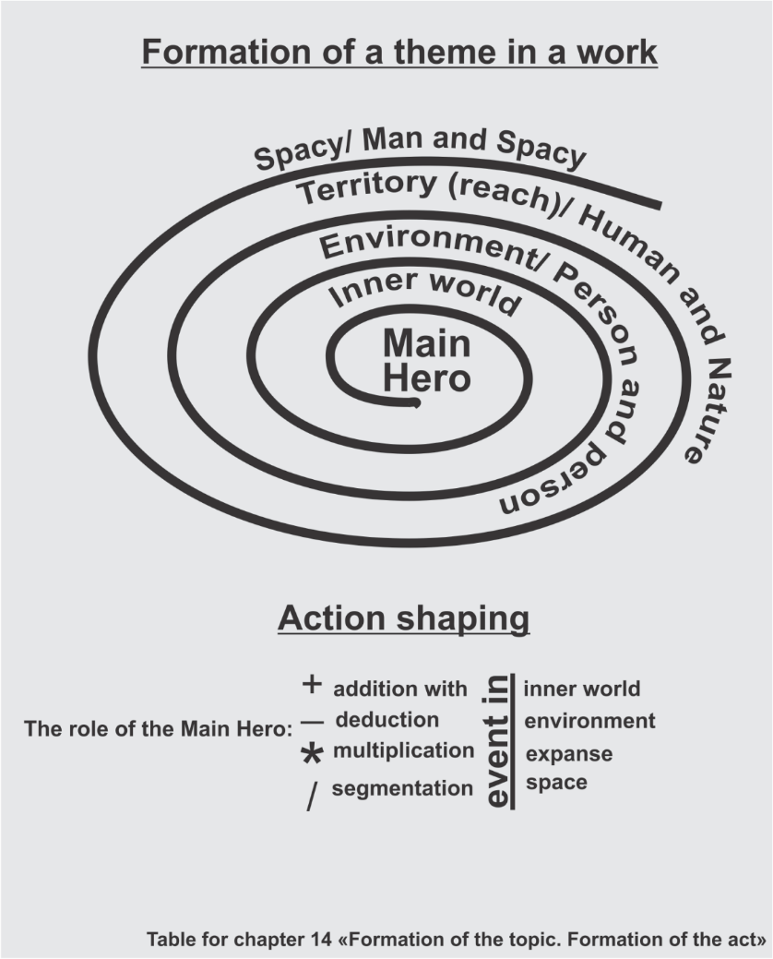
Famous writers treated the formation of themes and plots as follows:
Jorge Luis Borges in his novel "The Four Cycles" gave the world the reasoning for only four plots, including all the rest in them:
- Fight
- Return
- Search
- Suicide of God
Christopher Booker, in his book Seven Basic Plots: Why We Tell Stories, grouped all existing plots into seven, explaining that all the books of the world were written on their basis:
- From rags to riches (transformation)
- Adventure (difficult journey)
- Back and forth (attempt to return home)
- Comedy (a special type of plot that develops according to its own rules)
- Tragedy (its climax is the death of the protagonist due to any character flaws)
- Resurrection (a miracle saves the hero from the power of the curse)
- Defeat the monster (fight and win)
Disputes in search of topics, plots do not subside. Maybe you can submit your list, which will become a history.
While working at YourAmir Publishing, I proposed a modern list of topics for non-fiction to help the authors take part in the Annual International Book Award "Your Book":
– Experience of victories, achievements, hobbies
— Blockchain. Investments. Cryptoeconomics and the future of business technology and law
— Technologies, life coaching
— Psychology, psychoanalysis and coaching
— Knowledge of the world and the laws of the universe
This project is under development and may still find its application.
Fiction, children's literature, science fiction cannot be limited in the topics presented, as the attention is already focused on the quality of the material and the writer's ability to show his colorful world. Therefore, for artistic works, the list of topics has only moral and aesthetic limitations.
You should remember about the purpose of your book, which is not addressed to a narrow everyday problem, but to solving ideologically directed issues rather than global ones. By ideology, we will understand not your political views, but the ideological component of your life. After all, your book is your faith. You can describe only what you believe in. You trust the book your content, your understanding of the world. Through the work, the position of the author, his attitude to what is happening is always visible. It is hardly possible to depict this in isolation from the time in which you live. Therefore, by presenting the formed images around the main character, or the main idea in non-fiction, you show your position in this world. None of the positions can be called unprincipled. A representative of any class, religion, philosophical principles will set forth his evaluative position in his book. It happens not only through dialogues or through monologues. It is possible to see the position of the author through the description of the interior, landscape, view, and even veins on the hands.
The idea of ​​the work passes through the entire canvas of the narrative. It emphasizes integrity, therefore it is important not to leave the central ideological line, to save energy for other books. In this work in contrast concentrate and unwind, like a ball of thread, your main idea, but do not immediately put it on display, otherwise the work will end there. A portioned presentation of the main idea should leave the reader the opportunity to reason, and somewhere even to draw in his imagination his own outcomes of a particular situation.
Socially significant ideas lie on the surface. Their relevance is determined by the time in which you live. The denouement, the solution of one or another idea, may turn out to be fruitless, with the so-called "open end". Such an ambiguous presentation of the idea is shown by L. Tolstoy in the novel "Anna Karenina", demonstrating the acceptance of different opinions, different positions.
Pay attention to the veiled expression of thought through the epigraph. A short, concise statement can become a spotlight, illuminating the central position of the author.
So, through the concepts of theme and idea, we arrive at the language of the book. The theme is not simple, as is the life of any human being who fills himself with rules, observes the course of events, and historically inherits change.
Describe the main idea of your book, and then the main theme of your book:


Chapter 15. LANGUAGE OF A LITERATURE WORK
Experimenting with the theme of "language of presentation", I came up with a collection of stories in which the heroes of our time use the language form as signs. (Collection of stories "Felt-tip pens for Titian") They represent slang, dialect, jargon and even the expression of silence, arrogant speaking, rustic brusque and curly speech, monologues and quiet dialogues of the intelligentsia. How shall we write to convey an idea? How shall we formulate a speech so that the reader get an image easily and unmistakably and fold puzzles into a single picture? I still doubt if it worked. What can the reader see behind this form?
I recall the examples described in the literature, how F. Dostoevsky groped, and then, having found, polished the idea of ​​​​writing the novel "The Teenager": "In my own name or in the name of author? In my own name is more original and loving, and more artistically required. In addition, it is terribly bold, the arrangement is shorter and simpler, and the character of the teenager as the main character is clearer... But won't the reader get tired of this originality? Can a 20-year-old writer express the main thoughts of the novel naturally and fully? In first person, from the first person, from me! ... In my own name or not? In my own name ".
Doubt, think, look for and find your hero, participate in his life, bear responsibility for him as for yourself.
Your characters' speech depends on their personalities. Note the hero's habit of repeating the word here it is the identification mark of this character. Corruption, drawling or, conversely, rapid spasmodic speech, mumbling or confused, exciting pronunciation all this will show variety and indicate distinctive features.
What guides the writer, depicting one or another character, one or another phenomenon? What do you base your image on? Undoubtedly, in your stock there will be images acquired through the experience of meetings, reading literature and in real life. How do you know if the work has your unique language, or you have not found your individual guide to lead "your hand" while you write?
The search of own style, unless given by nature, is not assimilated as quickly as one would like. One of my teachers made us, processing an array of works, biographies, critical articles about certain writer, then write out, imitating his style. Feelings of discomfort push you out of the imposed style, and these very moments you begin to realize what is close to you and what is unacceptable for you.
The most surprising thing is that critics do not have objective methods of literary and aesthetic assessment of style. Pay attention at the terms "literary-aesthetic". Yes, aesthetics and cultural studies come into force at the moment. Huge layers of science must enter you in order you gain confidence that you obtain your writing style without requiring third-party evidence and evaluations. The critic will only appreciate how your work fits his own picture of the world.
The writer's style is peculiar style of presentation. It corresponds to the elements of the epoch, national characteristics of, combining individual, general, artistic and documentary-historical. As for the great authors, one can often hear that being the mouthpiece of the people they expressed and reflected the will of the great power. You can wonder why a contemporary should be a mouthpiece. You will be right in your own way. The crowd, the people, the mass is your author's side of preferences or protests.
I remembered our conversation with the writer Alexander Kabakov at the Frankfurt Book Fair:
"Who do you write for?" - he asked, "if you write for the crowd, you will never become a real writer..."
Such is the paradox of the eras in which the writers who became famous a hundred years later developed.
Another peculiarity of a writer is that the style of one work may differ from the style of another of his works. This depends on the focus of the text, its themes and ideological features. Remember that the language of your work is just as important as its ideological component, and, of course, following the chosen theme is important. Therefore, the visual aids used in your book require some refinement. In time you will get the hang of it. You will find more information on this subject in the next chapter.
But at the end of this chapter, I encourage you to review the "Literary Hero Skills" chart in the "CHECKLISTS" section. This table will tell you what skills you can give your characters.
What skills does your main character have?



Chapter 16. METHODS OF DISCLOSURE OF LITERARY IMAGES
The purpose of any information becomes a value when you receive and then transmit it:
- internal markers (knowledge, experience)
- external markers (perception, observations, tendencies)
- genetic code (mission)
The means of transmitting information in prose and narrative material are diverse, these can be:
- details
- artistic tropes (metaphors, refrains, hyperbolas-litotes, alliterations-assonances, etc.)
- quotes
– portraits
- dialogues
- monologues
- lyrical digressions
- callouts
- references
- circular, spiral, dotted, etc. framework
- rhythm, tempo
- color rendition
- etc.
Concentrate on an event in your life that surprised you, made you laugh or scared, stunned or puzzled you.
Any one event.
Retelling it to the interlocutor, you seem to dip each word in the same color it colored your perception at the moment of confrontation. Colors in words and their combinations are artistic and visual techniques.
The expressiveness of the techniques will be brighter and richer if you concentrate in your imagination, draw a repetition of the picture inside yourself, and then translate, trace this image into words, meanings. If you want the transferring feelings to repeat, find the most significant forms of conveying the words hue. The expressive coloring of your speech or the speech of your characters transmits through the expression of words, sounds, signs. A sluggish transmission will give the same sluggish perception.
Tell the difference between person coloring and coloring in the description of a group, a company, a crowd, a collective. In the second case, completely different shades will appear. Their motley palette will give you a mess of different characters that cannot merge into one image. You, as an author, must create relationships between these people, or objects as well as, with phenomena, images, time, and space. Use in the description not only what you saw, but also heard, tangible, felt. Describe not only what is seen "on the forehead", but also cover what is happening around. Create a panorama description.
The vile phrase "He saw Lisa running towards him" can be used if the intensity of the text is so great that all that remains is to cut with facts, where the action and the subject are in the foreground. But if you need to convey a state through a phrase and bring the reader to the feeling of this state, turn on all possible receptors using head turning, breathing, look at the objects that flashed before eyes, and even what is out of vision. Note that we rarely look at one point, especially without blinking, unless, of course, it is description of a mental illness. There is undoubtedly movement in the word "running", but neither the strength of this movement nor the character of the heroine is shown. Might she be lame or clumsy? Or might it be just a dog... Try not to turn on all the lights of the imagination, describing the character, at the same time, highlight only the details necessary for this moment.
As you can see, becoming a writer, you master a lot of other professions. In this particular case, you are the "illuminator of the plot" look carefully at where the light falls on your character. Describe the state of the incident's rays so that the reader understands not only the location of the event, but also the time of day, the day, the month, and, of course, the year. In these handouts of the absurd, you become a psychologist, a statistician, a filmmaker.
The territory of the event- space - time: let your reader constantly feel these three components.
Return to the topic "portraits of heroes" and once again work through the dossier for each hero. This will help you not only to be familiar with your characters, but also to be their mom, dad, best friend, person your hero has entrusted the most intimate. Based on this dossier, form visual techniques through dialogues, through unraveling situations and making decisions.
Set yourself the task: to learn to see the depth of the text, to learn to hear the depth of the sound of each word spoken in the work, to learn to feel the depth of life.
How?
Through the filling. Through observation. Through the lens of yourself. After all, you write in the rhythm of your heart, in the perception of your hearing, in the explosions of the cones of your vision.
Pay special attention to details. A detail is that component of a situation or state that will instantly allow the reader to get inside the text, where you will open room after room for him and lead him to your treasure.
A detail can emphasize, add touches to the hero's awareness of the created situation. If the hero was reading calmly and suddenly abruptly closed the book, this detail may show:
- character (for example, a certain time was given to reading...)
- temperament (e.g. nervousness, anxiety, agitation...)
- a memory of something...
Clothing detail can indicate the character traits of the hero and even the events that are taking place. Try to avoid meaningless details described for yourself. Each detail seems to tell, complement the described image and lead to a conflict or its resolution.
At the same time, in a skillfully constructed text, a detail, like a fractal, will create great in a small matters. Details can also become symbolic references, metaphors, but this is already the author's precise work. References are closer to a cinematic look at the details, a picturesque presentation of an episode, with a certain layering and extension of the image.
For example, from the image of an airplane-cross in the sky, the image narrows in words to a pectoral cross. Or, for example, turn a window into a picture on the wall with the image the hero needs. Or consider, for example, the relationship between a tree and a hand.
Practice seeing other phenomena and even events in the same object.
Comparisons lead to another detail of the text - the active use of synonyms, antonyms, homonyms, paronyms. The synonymous "expansion" of the picture will help the reader to get a range of taste sensations that most suits him from the perception of words.
Hyperbole and litotes exaggerating or understating details and events around the description of characters help opposite the images. Thus, the deeds of the hero become acquainted in comparison and in volume, in meaning and insignificance.
Another characteristic detail is the use of color. The psychology of color is of help to you! Not only the well-known Luscher tests the most accessible research for the modern understanding of color can come in handy in this case. You should also consider the historical perspective on color. Indeed, color relationships did not always coincide at different times, in different parts of the world.
The symbolism of color is a great assistant to the writer. Through color, one can convey attitudes towards certain events, characters, and even interethnic features. The color palette is diverse and therefore the use of primary colors, which include the seven colors of the rainbow against the background of the color spectrum, along with white, containing the entire color gamut, and black, is no longer enough.
The writer should be careful, as the color combination can lead the reader to the wrong meanings differ from what the author had in mind. The color itself, isolated from other colors, may indicate the processes of loneliness, thoughtfulness. Color in combination is one of the ways to demonstrate desires and fantasies.
However, color symbols are not only the prerogative of your taste sensations. You need knowledge about time influence on color characteristics.
The roots of color perception go back to ancient times, to those times when a person learned to use the colors of nature, starting with a minimum of combinations. At the same time, the ancient and modern interpretation of the same color may differ.
For example, white color in the antique tradition means goodness, happiness, life, well-being, and in the modern world, white color can be the direction of illness and a premonition of death. But again, it is not true for all nations. Black means gloominess, dirt, chaos, evil, darkness. As opposed to white, black in combination with white acquires the philosophical meaning of harmony, where good and evil are two sides of the same coin, one field, one life. Red means blood, thirst for passion, fire, but also beauty, strength, courage, and the color of scaring away evil forces. Red is "the third river of the supreme God" after white and black.
The symbolism of the color of ancient perception affects the seasons, the elements, and even corresponds to animal symbols, musical sounds, days of the week, chakras, for example, according to the theory of correspondences of the Book of Changes (I Ching). The same for the meaning of the number "seven", which contains the symbol of cycles: a rainbow of colors, the division of time into weeks, musical harmony. In its turn the seven-part division intersperse with the system of “four”: the seasons, the elements, the wind rose, etc.
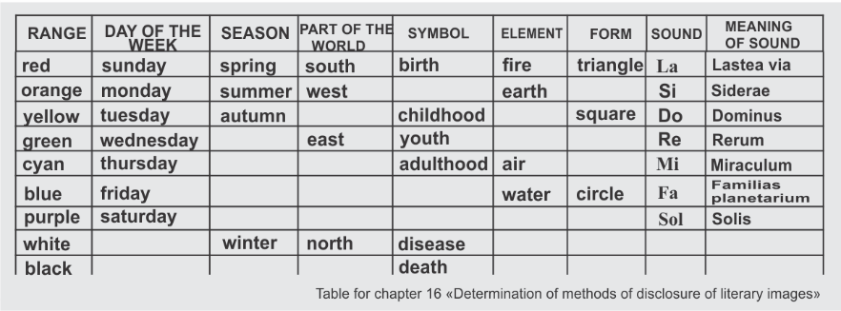
Please note that the reader's perception of color can be individual, and depends on his psychophysiology. Therefore, your responsibility as a writer is to cause no harm.
Different eras, different religions correspond to their color characteristics. You should carefully consider the matter if you want to use color schemes in descriptions scattered across historical intervals.
So, for example in the Enlightenment, new variants of color symbolism appeared, with other forms of color content:
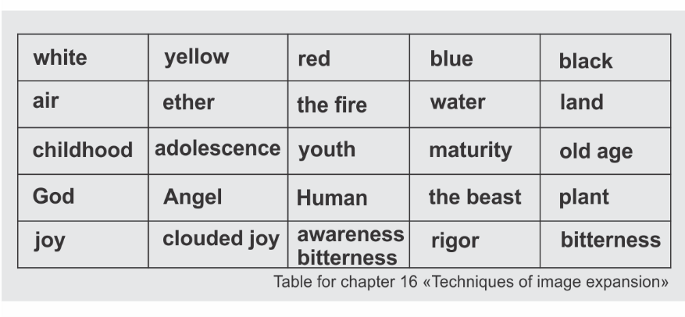
The poet I. W. Goethe attributed color to a building material that affects the mood of the soul. Its "positive" colors - yellow, red-yellow (orange) and yellow-red (red lead, cinnabar) and "negative" colors - blue, red-blue and blue-red differ. The first give vivacity, an active mood, while the second are sorrow and anxiety.
The beginning of the 20th century interpreted colors in its own way:
Blue-violet (according to P. Florensky) - the world soul, the spiritual essence of the world.
Red-pink is the image of the Christian God.
Green-gold - "neither to God, nor from God, but around him."
Black is the meaning of revolutionary fanaticism.
Black with red is the color of terror and political repression.
White - means an "idea" and opposes no longer black, but red.
The modern world has endowed the color scheme with features of psychological content. The color palette allows you to convey a mood or character through a wide synonymous series, where the main color is decomposed into shades that convey the power of emotion in ascending or descending order, where:
Blue - sea wave, turquoise, sky blue, lavender, niagara, azure, ultramarine, cobalt, sapphire, etc.
Yellow - gold, olive, amber, pumpkin, mustard, saffron, lemon, corn, brass, etc.
Red - coral, tomato, salmon, brick, burgundy, raspberry, brown, etc.
Each color shade corresponds to a different character.
Remember also that modern architects and designers have their own color classification, while physicists and musicians have another. It is a pity, of course, but the roots of inconsistencies are visible in history. As a linguist and music theorist, I am concerned that modern architecture does not take into account the correspondence of color to musical sounds according to the Pythagorean theory. I accept the Pythagorean interpretation.
Much depends on the territorial location of the object or character. Residents of the south, for example, where there are many warm colors, prefer cold shades in the interior and clothing. While the inhabitants of the northern territories are completely opposite in the preferences. They also have much less details than the southern ones.
It is not about associations. You should familiarize yourself with and additionally take into account the theories recognized in history by leading physicists, philosophers, linguists, and later by well-known architects, designers and psychologists. For example: W. Winch, V. Kandinsky, A. Hard, R. Adams, E. Delacroix, M. Chevrellet, I. Itten, A. Mansell, F. Runge, I. Goethe mentioned above, G. Grimm, I. Newton, Paracelsus, Pythagoras, Aristotle.
Knowledge of symbols, heraldry, ritual practices and, of course, philosophy can add to the experience of details rendering.
Your book, as we have already discussed, can carry not only a cognitive orientation, but also an operational one, encouraging to action. After the performance of the operational and cognitive functions, we connect the emotional (expressive) and aesthetic functions. If all four types of information transfer are involved, you can claim a qualitative perception of your book by the reader.
One may wonder: is it necessary to use artistic and visual means in the annotation? The annotation to the book is a transcript of the purpose of the information that includes author's genetic code and markers. A good annotation is a guide to the worldwide coding system. You carry out screening and assessment of the value of a particular book according to the annotations. At least at the first stage. Therefore, we have already spent a lot of time trying to understand what an abstract is. Now, having gained knowledge from the previous chapters, you can return to the written annotation and reformulate it. Do not put a limiter in front of you. When the text of the annotation is polished, it will indicate you about it. Therefore, continue to work on its formulation throughout the writing of the book.
Description is one of the most important artistic and visual techniques. Put the concept “drawing” into the term “description”: draw with words, draw a picture with sentences. I really like the classic example in which one young writer depicting a cramped little room, listed all the items in it, but did not achieve the sense of constrains. When they told her about the absence of a feeling of tightness, she was indignant and uttered a phrase: - Why on earth it is not cramped if I barely squeezed through its junk with my hand luggage! Only two successful words "junk", "squeezed", depicting the volume, gave a complete picture.
The sketch presented below was the completion of the task - to describe the human ear with artistic and visual means.
AN EAR
Etude
I studied his ear carefully. Tomorrow, I suppose, all my colleagues will laugh after me.
From the very morning, greeting the students in the class, as if casually assessing “whether this ear suits me as a subject of description or not”, I looked away from the eyes of the students to the left, then to the right, as if choosing a suitable fruit in the market. Neither ear aroused much interest. At the end of the working day, a security guard came in to ask how long I am going to stay in the office, adding that I am last one. Without having time to say a word, my gaze made a trajectory from his eyes to his ear. Here it is! It deserves not only thousands, but several thousand signs of description. A huge, with a plum-shaped bent down lobe, the ear was covered with gray hairs like strings sticking out in different directions. The contoured ear looks like a violin shell. The ear was not just attached to the head - it towered over the shoulders, as if on a pedestal. The dome of the skull was its crown. The guard standing half-turned to me was waiting for an answer. Indeed, it was his ear that was waiting! An ear stretched out in my direction, captivated my eyes with chains of silent admiration. I remembered someone's words that the height of the ear of genius people should be more than twelve centimeters. The size was impressive. A deep shell, shaded by ledges like a pit among canyons, rhythmically moved in and out. The hairpin, that covered the gaping darkness of the shell, went obliquely to the cheekbone - the ear was saying something. At that moment, the realization arose - my locators tuned to the wave inside me and external factors are unlikely to be able to return to reality. Stepping back without taking my eyes off his ear, I sat down in a chair:
- Do you want some tea? - I asked the guard, but he, gurgling something in his mouth, strained such a grimace that his head, like a transformer, turned around and all the protruding beauty of his both ear "barricades" appeared.
“…Go home already,” the guard muttered, and his imposing ears switched places and disappeared behind the door.

Now it is your turn to describe the most important event in your book:


Take a break and describe an event that is its complete opposite. Watch how shades, colors, details change.
We laid the contour of the book at the first lessons, when we wrote out the parts and chapters. The so-called "lyrical digressions" are also important for the book (especially for non-fiction all the more!). There is no need to focus on the word "lyric". If it is, for example, a book by a financier, then some facts, “wise thoughts” (own, of course), figures, calculations, significant dates, tables, etc. can become “lyrics”. The general name of such things is “lyrical digression”.
Of course, the general concept of the book must be taken into account. It would be inappropriate to see a lyrical digression in the form of a funny story if the main speech in the book is about numbers and formulas.
The number of lyrical digressions in the book should be reasonable. Their internal logic implies no more than three types of "excurses" from the main theme that are additions to the general context.
Do you remember we talked about creative and non-creative contexts? We consider the entire book in two planes of context: from the position of the transmitted idea of ​​the work and from the position of the author as a person.
A medium-sized book should have about three themes of lyrical digressions. One will need more attention. Like a red thread, it will run through the entire book. As for the text layout, it might look like this:
For 25 chapters: 7 lyrical digressions of first degree + 4 second degree + 2 third degree.
They must have an opening and lead to conclusions. The introduction is usually textual, while the conclusions can be formulas, tables, summaries, and "totals".
Lyrical digressions of the second degree are your strong phrases. They can be "pulled" out of the text at the time of the compilation of the chapters of the book.
Think about the third type of lyrical digressions for yourself: what could it be?

Chapter 17. ENERGY WORDS
I have already mentioned that when structuring texts for readability it is now necessary to pay attention not only to the accuracy of the formed phrase, but also to its sound filling by letters.
Sound underlies not only letters, words. Sound is the basis of our life. Thanks to the power of sound (explosion), according to one version, the appearance of the planet Earth occurred at the chemical level. Thanks to sounds, we have the ability to attract or reject pleasant and unpleasant. Sound is a sacred formula of human life that has yet to be unraveled. Sound can become a "drug", which liquefies the structure of the cell. Sound can be both harmful and beneficial. The antagonist of sound silence is the absolute, which we appear from and which we go into, and it is still under study. However, harmony is possible only when puzzle is completed. This is what we will strive for. So our next puzzle is sound.
Thinking about the topic of sound, since one of my professions is a musician: piano, solfeggio, guitar, music history, I managed to deduce several sound theories. They are isolated, but there is probably a precedent for further research.
Each of us is a set of sounds. When describing a story, a fact or an event, you involve not only the object of description, but also yourself in that moment.
Here are my observations about people: your personal irritation will make your brain tell you words containing the letters "r, sh, s, h, e"-they are hysterical, brash, nervous. This applies to speakers of Slavic languages.
In the case of English, German, or Turkish, they will be answering, guttural sounds.
The calmness inherent to the smooth flow of the text, on the contrary, minimizes these consonants, and they will be replaced by anterior labials “s, p, t, v”.
If you want to soften some sharp corner in the text, use words with sonorant consonants "l, m, n" (anterior and middle lingual, middle palatal). Knowing this "secret", you will already be able to manage your emotions in the text.
By "working" in this direction, you will soon notice that your speech enriches, as if you have added a breath of fresh air to it.
By controlling the sound content, it is possible to build (fill in) the sound (phonetic; sound is otherwise called a phoneme) structure of the text.
Take for example a three-part presentation of the material in one chapter - 1. introductory part, 2. main text, 3. conclusions. Let us consider what conclusions the reader can make emphasizing its phonemic content:
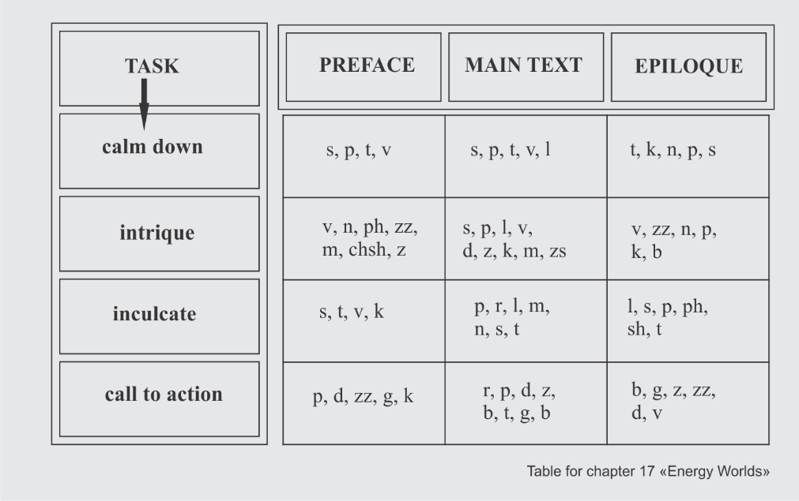
This is the magic of sounds that you can “launch” inside yourself if you think about the energy of the text.
Of course, it makes no sense to count these or those used phonemes, but it is worth thinking about.
There is one more "secret" how to "fix" some important detail. As a rule, in any form of description, whether it is a whole story or an episode, its main idea is expressed in the first paragraph. It is like the thesis that you put forward. Explaining with further text, you build an “evidence base”, and then draw “conclusions”. In a literary text, the conclusions are not explicit, but still implicitly present. So, to reinforce these conclusions, play around with the main phrase of the first paragraph in the last sentence. It will set the reader up for some satisfaction, and sentimental people (if this is a literary text and the emotional intensity of this part is strong) may shed a tear.
So, take the first or central phrase of the paragraph as the key to this text. Inserting it at the end will leave a pleasant aftertaste.
This technique is called the "circular framing rule". You can call it differently, based on philosophical tactics. However, it is present in almost all masterpieces of art - in painting, music and literature. A "circle" is the right shape if you're looking for harmony. If you want to spice things up, a triangular shape is better. Calmness and evenness will give an "oval".
The following lectures discuss "triangles," "squares", and other shapes in the text.

Chapter 18. DIALOGUES
Dialogues greatly enliven the texts. They are an integral part of a well-structured text. The author should strive to use all possible means of transmitting information, including dialogues.
Dialogues divide into main and secondary.
Through them, the nature of one or another character is revealed through gestures, intonations, movements. This is how secondary dialogues work. The main dialogue should have such a degree of tension that will lead the reader to the climax, to the high point of the relationship.
"Vivid" dialogue always accompanies the development of the plot, reveals the speech of the characters, showing them in communication, which should carry the function of a tense nerve, where the characters clarify the essence of the moment. At the same time, each hero is independent and speaks "in his own language."
Through dialogue, unpleasant features of the characters or, conversely, sympathy are depicted directly or indirectly. The reader will guess about the perception through the created situation. In the dialogues, the writer, thanks to the painted picture of communication, "passes by" moralizing and edifications, which should be better avoid in works.
One of the authors, describing a visitor to the office, through dialogues, including inner one, vividly showed the essence of the character of the heroine. Some of the readers will try on this character, and someone will use the theory "on the contrary" - "I am not built that way." However, for both readers, this episode will “stick” in memory, because it is “lively”. The dialogue gives this described situation richness.
MONEY AND JAM
Early in the morning, a respectable woman, one of the fund's donors, came into the office. I was alone in the office. She enquired about one of the employees, and I offered to wait for him. Continuing to work at the computer, with peripheral vision I caught her cautious movement from one chair to another towards me.
- Do you want to know something?
In surprise, Asya (as she introduced herself) froze and immediately moved sharply two chairs closer. She beamed, drawing my attention, and after a little hesitation, she blurted out:
- I see in your eyes - you are an honest and intelligent person! ... And I'm calm about my money, but I don't understand how it increases?
- ... Hmm, tell me, do you put up jars? I asked, being all eyes on the computer screen.
The established silence made me look up at her and smile. A slight pause of bewilderment raised her eyebrows, but a moment later, a smile broke out in response. This was followed by a story about how she managed to freeze raspberries this year, cook strawberry jam, pickle several types of mushrooms. She told about the canning technology so that the lids do not swell. To my question "why doesn't she buy ready-made canned food in the store?", she answered that her son-in-law and grandchildren liked the goodies she cooked more.
I also developed an entrepreneurial interest:
- So why don't you make a cottage industry, and not screw canned masterpieces all year round just for yourself?
- Raspberries are the most delicious and cheapest only in June, - and added that in winter before the new year, she also sells her jam at a profit.
- How do you know all this? - I narrowed my eyes, and Asya, having already guessed about my cunning, smiled even wider.
- I have been living so for a long time, and from year to year everything is the same, because ...
- The same is with our experience... - I summed it up and added - The company's traders have been trading on the crypto market 24 hours a day, 7 days a week continuously for 2.5 years. During this time, we have figured out the patterns that we use to increase our total capital. We buy cheaper and sell when liquid assets rise in value, which we understand very well, just like with crops. This is how your money grows.
Joy on Asya's face spilled over her rosy cheeks. And then the employee she was waiting for came.
(text from one of the students)
In a book of 200 pages, it is enough to include about 15 general dialogues and 3 decisive large dialogues. Consider which chapters should contain these important dialogues. I can assume that, perhaps, more than one of such important dialogue should take place with the main character.
Major dialogues should not be extensional and turning into reflections. In fact, the main goal of the book should be the keynote of the main dialogues.
Real-time dialogue, or dialogue in which you convey interaction between characters, should be displayed with colons and dashes. Inner dialogues, monologues, thoughts aloud, as a rule, are enclosed in quotation marks, without a dash. You should know one feature of writing the dash sign.
"Major dash" is always placed before the dialogue. If you work on a computer or laptop, then the "big dash" sign is placed not with the "dash" button, but with the key combination "Ctrl +" minus ". So, examples of the design of dialogues, where "P" is direct speech, and "a" are author’s words:
- P, - a.
- Hi, - G. smiled.

- NS? - a.
- Would you like some coffee? - asked M.

- NS! - a.
- Hey! - smiled G.

- P ... - a.
- I do not know ... - answered G.

- P, - a, - p.
- Hi, - G. smiled, - glad to see you.

- P, - a. - NS.
- Hi, - G. smiled. - It's good that you came in.

- NS? - a. - NS.
- Sure? - Asked M .. - There will be no second chance.

- NS! - a. - NS.
- I do not know what to do! - almost desperately, cried out M .. - First of all, tell yourself this.

- P ... - a, - p.
- He ... - G. hesitated, - he will still be able to show himself.

- P ... - a. - NS.
- I ... - G. hesitated. “I don’t think this is a good idea, M ..

- P, - a. A: - P!
- I agree, - G. nodded. After taking a couple of steps towards M., she added with a smile: - I think you will succeed!

- P, - a. A. - P.
- I agree, - G. nodded. M.'s face showed surprise - he obviously did not expect such an answer. “I think it's time to start.

- NS? - a. A: - P.
- Sure? - Asked M. For several minutes, he stared at G., after which he warned: - There will be no second chance.

- NS? - a. A. - P.
- How so? - G. was surprised. Hearing the tone of her voice, M. turned away. “I don’t think this is a good idea.

- NS! - a. A: - P.
- Fine! - M grinned. Having carefully looked at G. from head to toe, he concluded: - Now you need to buy a new dress.

- NS! - a. A. - P.
- Wow! - was delighted G .. M., seeing her reaction, smiled. - In that case, I also want shoes.

- P ... - a. A: - P.
- Hmm ... - M depicted surprise. After thinking for a minute, he agreed: - All right, then.

- P ... - a. "A?" - NS.
- Coffee ... - G. was confused. "Are you really? There is so much to worry about?" – I’d rather not.
In fact, there are many variations of punctuation marks replacing each other. You should know the basic rules of writing: author's words are written after a comma / ellipsis / question / exclamation mark with a small (capital) letter.
Make up your main character's major dialogue with the main antagonist:



Chapter 19. Dirty words
The theme of focusing on “dirty” words, or as they are also called “parasite words” or “junk words” is quite popular. At my time, a selection of articles and books by William Strunk, Viktor Shklovsky, Robert Mackey, Krzysztof Kislowski and others helped me to understand this topic. The advice of not only writers, but also film directors and playwrights helps to consider the "word" from the verity of angles.
Dirty junk clogs up text in an unpredictable way. Identical words from one sentence strive to jump into the next. And, of course, those personal pronouns! We have overloaded our thoughts (text) with them so that at every step (can thoughts walk?) we stumble on our own phrases. Dealing with impediments to correct perception is one of the rules of the writer. It is important to let the text "lie down" for a day or two, and return to it with a "cold gaze". Sloppiness in the text are similar to the things scattered around your common place of residence. And If this does not annoy you, it may not suit your reader, whom you simply need to, if not love, then at least respect. You seem to be deliberately dismissive of those who are at arm's length with you and do not give them the opportunity to finish reading sentences due to:
- frequently repeated words
- predominance of pronouns
- demonstrating your own uncertainty, which you express with interjections and introductory words
- long "caterpillar" sentences
- and "cold" words.
Do you see how I “walked” through the text above, removing the excess with a strikethrough? Without the crossed out words, the text was not affected.
Let us look at another example of how to deal with junk words.
And If this does not annoy you, it may not suit your reader, whom you simply need to, if not love, then at least respect
- Ruthlessly get rid of unions "and, but" at the beginning of sentences.
- Leave only the most significant pronouns
- Get rid of repetitive prepositions, words
- Replace repetitions of the same words in two or three adjacent paragraphs
- Long "caterpillar" sentences are better to split up (unless, of course, this is not a feature of your style)
- If the meaning of the paragraph does not suffer from getting rid of the entire sentence, feel free to delete it.
In this case, you see that the sentence, despite its expressive coloring, repeats the meaning of the next one in the paragraph, so you can do without it.
You can use "junk" words, but do not clutter the text with them.
A. Olshevskaya gives an excellent thesis about words-parasites in one of her works:
“Words-parasites absorb the vital juices of the book, and left the reader only with a dried, flabby shell. Fortunately, although this disease is widespread, it is easily treatable (unlike other serious illnesses such as megalomania, chronic illiteracy and the diagnosis “I am the author - I see it that way!”).
Obviously, prevention is the best remedy. If the text is infected with parasites, then with proper sanitation, it quickly gets better. Its author acquires strong immunity. "
Allow yourself a few five-minute daily workouts for twenty-one days, and you can permanently get rid of such words even in speech. You can find a dictionary of expletives on the Internet or in the library in the writings of William Strunk, this will be a very useful acquaintance.
Words become parasites when the author is too absorbed in clarifications. For example, the pronoun "your" already confirms belonging, and any clarifications around it can only do harm. Let us analyze the sentence:
"I stretched out my hands and took this small rolled up lump on them."
Excess is easy to spot if you read the sentence aloud and visualize the action in your mind. In an imaginary picture, you can see a certain "I" picks up something or someone. The main words of the sentence specify the subject (who? what?) and the action (what to do? in different tense forms). Secondary words describe an additional object (what? who?), the qualities and quantity of the object (what? whose?), additional characteristics of the action (what did he do? what does he do? - in different tense forms), exclamations, phrases, forms of negation, and forms of placement of words in space. This is enough not to clutter up the text with unnecessary information, especially in non-fiction. Descriptions of the literary text need more careful work.
In the proposed example, two actions occur - "stretched out his hands" and "took". When a person holds out his hand for an object, his intention is already clear. If you stretch your arms to reach, you need to be at a close distance, or below the object that offer you the "rolled up lump". So, you need an additional explanation, which will add one or more verbs to the first action. Out of context, the sentence needs additional clues. In this case, prolongation of the phrase "stretched ... and did not take" will give more emotional connotation. Otherwise, the extension of the action does not carry additional information and the presented verbs do not have a special emotional coloring.
In secondary words - "your hands", "this folded small lump, on them (on your hands"), you probably already marked the used words as rubbish - "your", "this", "on them": cross them out boldly!
What's left:
"I reached out hands and took the folded lump."
If the context of a given sentence requires additional adjustment, you can look for word replacements depending on the semantic load of neighboring sentences.

Chapter 20. Creative and non-creative context
The context always has a semantic orientation. Whether it is creative or not creative depends on many reasons. You, as an author, must learn to distinguish between these directions. We will only touch upon the concept of "creative and non-creative context", and we will talk about the depths another time, since the topic requires a deeper penetration.
The modern "word" has acquired a special volume in our time. We talked about it in one of the first chapters. By "word" we have agreed to understand not a unit of text structure, but a context. From now on, remember that context can be creative and non-creative.
H. Makhmudov was one of the first literary critics who raised this topic.
The creative context involves the second and third ground, as if you are watching a movie. In each frame you see the foreground and the background. There is not a single superfluous detail in the background, only what enhances the plot without drawing the reader's attention to itself.
So in your text, behind the words of the paragraph, not only the dry meaning of the main idea should be hidden. It should have the volume and convey the image of the events in time and space, in relation to the central character, and secondary figures using color, smell, sound, form, exposure. At the same time, references, epithets and other literary devices, including the writer's worldview and the depth of his thought build up a volume of the creative context.
Without opposing the concepts of "creative" and "non-creative context", I would like to explain the creative component. In the creative context, you should consider the existed high dimensional space, mentioned above, in relations to time and the influence of such relations on actions.
Any object can be considered in a spatial field as a point. If we observe the simple actions of an object, its movements anywhere, it is not a creative context. The actions of an object even designated by complex somersaults cannot turn this object into a creative one until you enlarge the object so that you can see not only its appearance, but also its thoughts, desires, needs. In this case, the impulses of the object to move in space and time may be of interest in the relationship.
I will try to deepen my understanding of the context using the example of the Tetris game. Why a person can be captivated with this game: your brain is zombified by simple repetitive, but seemingly complex actions. It's not a creative context that pulls you into a one-dimensional scheme. Creative context will give you depth, breadth, and height—i.e. three-dimensional understanding of the picture. The allusions and levels of knowledge hidden behind the text will give it depth. The ideological range stretches in width. The one whose analytical abilities will lead to new models of space will be able to comprehend the height.
I will try to illustrate the above with one example. At the beginning of the book, we discussed that “writing” and “creating” are different concepts. You and I create a book like an architect, modeling its parts, filling it with components. Like a builder, you build the walls of a building from a model. As a man in love, you tell the reader about your newborn baby. And, as an educator, you can retain through the book the goal that you consider the main thing in life. An illuminator, a sound engineer will help you highlight and designate objects, phenomena and the environment by artistic means. You will try on the role of friend and foe, jealous and villain, eccentric and lover. You will be everything and at the same time nothing because the world you have created exists only in your imagination. If you manage to save this super-world, pass it on to the reader, and the reader accepts and applies it, then it will be a creative context. It will be the field of your interaction, which is worth spending the precious time allotted for a lifetime.
The essence of the creative context is the initiation of the reader into your faith. He plunges into your world and surrenders to this faith. It is similar to the effect of music on a person. Accepting a congenial sound, you do notice neither time nor space, but you imbue and acquire thoughts uprush, comprehend some secret of an imaginary space. You are in the field of interaction that saturates and transforms you.
Only the sticklers to detail, who want to feel for themselves what they could not grasp, can intervene in this process and criticize it. In this regard, I will return to the topic of criticism.
Viktor Shklovsky (writer, literary critic, film critic) in one of his articles outlined a non-central, but very significant phrase: “We should not be ashamed to write.” It does not mean that you need to dump on the reader the entire array of your thought forms that have accumulated in your head. I propose to consider several meanings of this phrase.
The first one, and, in fact, “according to Shklovsky” is not to confine oneself in the description to dry facts, not to give the reader a meager cropped image. Reveal the character so that it is extremely clear, bright, original. After all, only this way it will become clear why he commits one or another action. The hero of the book appears in a real writer for one main reason - the world needs this phenomenon for transformations.
The second meaning is that the aspiring writer is ashamed of his material. He gladly demonstrates this to close people, but if it comes to a professional, then a certain block occurred. There is a huge plus in showing a manuscript to critic. The writer does not revel in his genius and understands that he has flaws and can correct them. It is necessary to understand and accept the purpose of the critic. Most people get the impression that the critic criticizes, harms, destroys, insults without appeal, and does everything to make you upset and never write again. That is what an amateur thinks. However, you are not a layman. You are an aspiring writer. Be aware that the critic is your assistant. If a professional critic works with you, it is happiness. His tasks are:
- to check the readability of the text (as opposed to the editor, who must isolate all repeated and "extra" words, offer replacement options);
- to look with a fresh, not "blurred" look at the place of the work in the literary process (as opposed to the editor, who points out the main failures or successful episodes, and suggests the way successful ones can be strengthened);
- to trace the compositional line of the work and digression (unlike the editor, who checks the logic of the characters' actions, and if it is non-fiction, then traces the logic of all the chapters and parts of the work);
- to help identify the strengths of the work and to suggest including them in the synopsis;
- to help in writing a synopsis;
- to write a review of the work and annotations;
- to be ready to distribute the review of the work in literary circles, including the professional sphere.
If your critic is a beta editor and proofreader, then he will be able to correct stylistic, punctuation and spelling mistakes in the text, which, believe me, even eminent writers make, despite the modern capabilities of the Word program.
Therefore, if you want to work productively with the text, send each written fragment for review, thus you make the work easier for yourself, the editors and save the most important resource - time.

Chapter 21. Text density and rhythm
The topic we are ready for now is text density.
Look at life around, at its natural component. As I said earlier, at every moment of your life you are surrounded by mountains, or steppes, desert, forests, sea or river. There is no geographical place that possesses all the above the same time. The same applies to texts. One text is a desert, the other is a forest, and the third is just a small step at the house entrance... How to fit the depth of sensations into the text? It is more the issue of psychophysics and cultural studies. Here we deviate from the creative context.

Do you remember from the school curriculum how density is measured in physics?
density = mass divided by volume: ρ = m/V, where m is mass, V is volume. The basic unit of substance density is kg/m3.

That is, density is the ratio of body mass to volume. We transfer this data to the text and understand what a mass of text is. It is clear that the content gives the array representing the main information. It should not be confused with the number of pages, since the body of text is no longer letters, but an idea that you bring through the work.

The idea is the foundation of the book, which we laid when we wrote the abstract. Now is the time to go back to the annotation and check it against what you are writing. Have you deviated from your intended course? Is there another idea mixed in that leads you astray?
The density of the mass of the text distributes in circles around the grain of the idea. You can compare it to the growth of an embryo, which develops gradually. In the show, the demonstration of the sequence, the readers perceive the text in its full logic and does not create the feeling of misleading.

Low text density is more common in fictional nature essays; in an essay, the idea is presented in the form of a thesis, and the main text explains this thesis. A book is not a single thesis, but a range of theses combined into one idea. Low density occurs when the author has "nothing to say", when he wanders around an idea with no evidence, no facts. Absence of facts means precisely absence of conflict. No conflict means there is nothing to talk about; there is no subject for conversation.

Events approach the conflict from all sides, slowly but well-directed. Thus, a tension of such force arises that the conflict cannot help arising. The content of the conflict flows smoothly from objects, their details, words, features of color and light, from the sounds of voices and the environment, from the idea and, of course, from the actions of the characters. The whole node of the listed elements creates density.
The density in non-fiction is determined, first of all, by your idea, then there is an arrangement of examples that have absorbed details, objects, their actions, sounds and light.
The rhythm of the piece is related to the density very closely.

“Everyone writes the way he breathes,” said Bulat Okudzhava in one of the songs. In this case breathing should not be consider as a metaphor. Breathing is a direct correspondence to the rhythm of the piece. Do not confuse rhythm with tempo. Measured at the beginning, accelerated at the climax, chaotic, breathless in the episodes of "checks", trials, errors, meetings, as well as dotted fragmentation and smooth flow of the text all the above is the pace.
Rhythm refers to the whole work and to its parts separately.
According to the law of harmony, we distinguish two main rhythms -two-part and three-part. The rest of the rhythms are based on them.

The two-beat rhythm and the three-beat rhythm consist of alternating strong and weak beats. The strong beat is your main character. Sometimes it can become "conditionally strong". Why? Because in some parts of the work, a strong hero can be replaced by secondary characters, and then he has little effect on events. It becomes "conditionally strong". In this case, a four-part rhythm will replace the two-part one, where a strong beat alternates with a weak one, then with a conditionally strong one and again with a weak one.
In the three-part model, a strong part alternates with two weak parts. A complex rhythm of three-part configurations: strong - weak - weak, conditionally strong - weak - weak.

Within the events, the alternation of proportions concerns not only the characters, but also details, objects, shades of colors.
Consider the inner part of the book as a process. Rhythm will begin to help to alternate the pace at which the calmness of the described events followed by emotional intensity. You can draw rhythmic patterns in advance and it will add strength and confidence to the book.

Once you have created an array of text outlines, you need to print them out and start laying out the sequence.
There is consistency in the structure we created in the first lessons, but if you find it necessary to swap parts, feel free to swap chapters and parts. It is desirable to place two chapters of the same rhythm next to each other.
If at this point you decide to rename the book, you will have to edit the abstract again.
Remember, that with a new title, the abstract to the book may acquire a different semantic orientation.
Take the time to write a new annotation. Spend it now to clarify the main thing in the book and the secondary ones. Sketch out ideas that will lead you to new twists and turns.

Any new ideas?


Chapter 22. Layout and formatting
You may have heard the phrase “it is better to educate right away than to re-educate later”. It is like a literary message not to do double work. Therefore, you should immediately accept the rules for laying out working materials. A template created according to formatting rules takes into account many nuances in the appearance of printed products. In a properly formatted text, it is easier to find chapters, necessary phrases, to make punctuation and stylistic "measurements".

At this point, you already have a written chapter or its fragments. Let us learn a few rules for working in a text editor. We talk about Word program.
Although the book in the finished published form will have A-5 format, it is necessary to provide the publisher with unformatted text. So set for writing in A4 format that is a regular standard print sheet 29.7x21 cm in size. Create a new document. To do this, open the Layout/Size tab and select A-4 size. In the same "Layout" tab, select the "Margins" section and check the "Normal" box. You should choose portrait orientation.
Go to the Home tab, Styles section. For the book, we need several styles. First, let us look at two styles for book interiors. The first style is for the designation of chapters. The second style is for the main text. Try make it a rule, set it up once, and then all the above will happen automatically in this document.

Let me remind you elementary rules you may know:
- to go to the line below, just press the Enter key (the Tab key should not be used in this case);
- to put a space between words, just press the "space" key once. And if you want to check if you have inserted extra spaces, and generally “extra, wrong” characters, turn on the “¶” icon (you will find it on the main panel). If you find two dots between words instead of one, then it indicates that one space is extra.
Write the title "Chapter One". Figures in a work of art and works of children's literature should be written in capital letters, in popular science, business literature, scientific, fantastic and methodical one you can replace figures with signs.
Highlight the heading "Chapter One" or "Chapter 1". Learn to use key of selection. To do this, place the computer mouse cursor or laptop hand cursor in the center of the first word and click twice. The entire word will be selected. Now, without touching the cursor (or mouse), press the Shift key on the keyboard, and while holding it with the middle finger of your right hand, use your index finger to press the signs with arrows right / left / down (this way you will familiarize yourself with the direction), to highlight the desired text.

Leaving the text selected, go to the Word’s "Home" tab, where we need a panel with Styles (this panel is located in the center, with letters of different sizes AaBbVvGg). The current style on the panel is framed. Make sure that the text you are working on at this moment is highlighted! Hover the cursor over the Style in the frame, then right-click and select the "Change" option in the appeared menu.
Make sure that the text, the parameters of which we are changing, is highlighted! Next, we change the parameters within the style. They should be:
Name - enter the "Chapters" parameter.
Formatting - Arial, 14. Text color "black".
Tick the box "Update automatically". "In new documents using this template."
Save.
Highlight the "First Chapter" again and go to the same Style, and select the tab at the very bottom:
Format / Paragraph / Interval, where indicate the intervals "before" - 6; "After" - 0; "Line spacing" - 1.5. Save.
Then put the cursor after the letter "a" in the word "chapter" and press the "Enter" key. On a new line, write the title of the chapter (if your chapters have titles). Choose a Style for the chapter title. Name the Style "Subtitle". As a rule, it writs in bold size. Set the interval - "before" - 0; "After" - 6; "Line spacing" - 1.5. As a result, you get the following:
Сhapter1. Intentions. Genres of the work

Then you can type the text of the first chapter. Its Style with the name "Plain Text" or "Main Text" has the following parameters - Arial, 12; line spacing 1.5.
If you use inserts or text with a different image, also use Styles.
As a result, when all materials are marked with Styles, you can easily isolate all chapter titles, all inserts from the text.
Remember to save the document and make a copy of it.
Save the material in a separate folder, which you call "Working materials for the book", and the file itself is called Layout.
In this folder, you should already have collected materials:
01 Abstract
02 Title / s of the book and about the Author
03 Synopsis
04 Parts and chapters (excel) - titles
05 Hero portraits
06 Major conflicts
You will give your own name to the folder with the contents of the book.

Now, when you open a new document, when type it, the set styles should be set automatically (if you did everything correctly).
Practice mastering formatting styles.

However, do not confuse with the word "format", which is often used in the meaning of "clear up", "destroy".

Chapter 23. The ratio of form and content
Before the road to self-writing a book, I open for you the topic of a large section - the relationship between form and content.
We dealt separately with the topic "language of form and content", but the concepts are so varied and important that I cannot avoid the topic of the relationship between form and content. These two concepts are informative not only for writing works. Everything that makes up our life is in close interconnection of forms and contents.
Following from small to large, and returning at a certain point, you realize: the form is the fact of existence, the shell of life, and the content is what we fill it with. The form of a work or book is a structure with parts, chapters. You fill it with the content in the descriptions of the storylines, in the details.
In terms of content, fill the book with interpenetrating layers. I will try to explain this using the example of a container, which we will try to fill with contents of different qualities and properties: twigs, sand, tennis balls, wooden cubes, water, earth, fragments of cloth, cardboard, paper ... - everything that in your opinion can represent the contents of the book. If we place tennis balls at the bottom, then cubes, cardboard, cotton wool, paper, cloth, and on top we press it all down with earth and sand, the water may not fit into the container. And the voids between balls and cubes will remain unjustified! Every piece of the work must "work"! Try to lay the layers, after a little thought, then the filling of the container will become dense - do not dump all the balls and cubes in one heap, stick twigs into the voids and lay them with cotton wool, earth.
Thus, the content will correspond to the form, and you need to include imagination in order the form corresponds to the content.
If, suddenly, it happened that a person lived, and on his deathbed admits that his life was not successful: he wanted one, or the other ... but nothing came true. The sad outcome of disappointment occurs primarily in that person's head. Here, the spiritual aspect comes at the first place. Its form collapsed, not accepting its own content.
A harmonious relationship between form and content occurs when a person at an earlier stage of life realizes his purpose. The first docking is awareness. The unity of these components is relative, but mobile. The ratio of both leads to both harmony and imbalance. Harmonious interaction develops into the concept of happiness, and then (according to Aristotle) into bliss, where material form and spiritual content penetrate each other. If the book, has the balance between form and content, the reader receives satisfaction, the desire to live and create, to study the subject deeper. For those who take this path, theoretical understanding and study of the works of such philosophers as Plato, Aristotle, F. Bacon, R. Descartes, R. Boyle, T. Hobbes, Kant, G. Hegel, K. Marx and F. Engels, V. Lenin, L. Tolstoy, V. Belinsky, I. Vinogradov, M. Bakhtin, M. Mamardashvili, V. Kuraev and others will make difference.
So, what is the relationship between the differences and interactions of form and content? First, let me tell you about the form - as a spatially organized structure of a work.
The form can be internal and external.
The external form depends on the material that the writer possesses and the format in which he deals with the means of expressing to create the described picture (flat text, dense text, voluminous, compressed, rich, deep, liquefied, conventional, closed, impetuous, endless, open, sharp, conflicting, etc.)
The inner form elaborate the images of the heroes specifying their place in the system of universal values. What is the shape of the storylines?
If we distribute and show the varieties of forms (here you need to understand that the internal form is part of the external one, and they are interconnected), we can notice their similarity with the existing geometric forms. This is the essence of the interconnection of everything in this world.

External Forms:
The triangle - the text is flat with three characters in different aspect ratios (P + 2A, 2P + A, where P is the main character, A is the antagonist), impetuous, sometimes sharp, conflicting. The author of the work has already built Who is who.
The quadrangle - the text is flat, closed, conflicts are not expressed, mirrored, relationships are even, some features prevail over others.
The rectangular- the text is flat, stretched, closed, the characters do not intersect with their inner worlds, the characters are separated by aspects of dominance, but in parallel (age, social status, physical condition, etc.).
The polygon- the text is broken, sometimes flat, characters are of different levels, and are not united, the aspirations are the same, sometimes sharp.
The square - the text is flat, stretched, closed, each character has his own inner world, the strokes are minimal and conflict-free, and interests do not intersect.
The circumference (ring) – the text is flat, closed space, compressed, there can be one central figure (as a rule, the author-observer), acquaintance with the characters by demonstration, calibration, equidistance.
The circle - the text is flat, even, thinned, compressed, but limited in space, there is air inside.
The parallelepiped – the text that claims to be original, has collisions, but flat resolution.
A cube is a text that claims to be original, juicy, sometimes cloying, fundamental, oppressive with its power, strong, weighty, capacious, multitasking.
The pyramid - on a flat text, pronounced sharp corners-conflicts are based, the desire to solve one problem; it can be dense, voluminous, impetuous, but also diluted.
The cylinder - the text aimed at solving several problems flowing into each other, striving from depth to height, endless, open, internal conflicts - at the bottom.
The sphere – the text is dense, voluminous, compressed, closed, expanded towards the middle of the narrative, events develop around the center along the radially.

Internal forms:

The spiral - heroes are shown in layers, from bottom to top or in reverse order.
Broken line (zigzag) - heroes in continuous conflicts, resolved conditionally in the same way.
The ellipsis - heroes have no distinguishing characteristics (neither length, nor width, nor area), they are located at regular intervals.
Dotted line - the characters are sketched with a dot line.
Wave - the characters flow into each other.
The point - one hero, it is indicated flatly.
Line - a hero out of space.
Ray - a hero out of space, but in a monologue.
The segment - two heroes, united by one non-conflict event, are heading towards each other.
Corner - one hero, one conflict, shown from two sides, from different angles (view from the author's side and from the side of the event, or from the side of the inner world), a sketch without resolving the conflict.
The triangle - "three" heroes, but with rebirths; one hero with two conflicts, or two heroes with one conflict, or the traditional triangle.
The quadrangle - four heroes.
The rectangle - heroes in pairs.
The polygon is a closed space in which several heroes have united.
The ring - represents a set of characters, which the author-narrator observes equidistantly.
The circle is an agitated "crowd", a group, but in certain relations. There is no single main character.
The parallelepiped - the main character or the author unite a group of heroes, a crowd without conflict, leading them to his own understanding of the world.
The cube - the main character or the author solves the issues of a group of heroes in conflict, leads through thorns somewhere upward, to the unknown, to the endless future.
The pyramid - the main character or the author solves the issues of a group of heroes in conflicts, being on the same level with them, but leading through thorns to his goals.
The cylinder - the main character or the author leads the crowd, the group towards universal goals without conflict.
The solid sphere - many heroes, all at different distances from each other, closed in one space, in one idea, close to each other. There is no single obvious protagonist.
The form is a means of solving the problem by the writer through the means of transmission, that is, through the language. It is designed to express the essence of the content and show the skill of the writer through the word. The reader, having his own ideas about the aesthetic values, first perceives the form, and then the content. However, the writer, as a rule, first forms the content (from the idea of ​​the work), and then the form is built.
You can see from the top list that some outer and inner shapes are the same. The interaction of internal and external structures form their own figure. It makes no sense to talk about ideal forms - their existence can be equated with the search for the absolute. One thing is clear that the form of a dense harmonious text is spheres in a sphere. The “air” between spheres in the form of lyrical digressions will oppose to the shape of a triangle in the sphere. In this case there is a conflict confrontation among a mixed crowd, which can only be resolved if one of the positions will be accepted.
The theme of form and content is deep and interesting, but not fully understood. There are no ready-made recipes how to write in order to find "your" form for your content. (Note that in the phrase "your content" the pronoun "your" is not in quotation marks, since as well as in the "Form and Content" topic, there is philosophical aspect. It is a delusion if you consider the content "yours").
This topic is worthy of an entire dissertation, so we will omit a lot. Let us move on to the general understanding and purpose of "content".
The content covers those elements of the work that express knowledge of the essence of life phenomena (the theme of the work), and their intellectual and emotional assessment, the author’s attitude towards them (the idea of ​​the work).
The content answers the questions: what problems have you identified with your work, how deep have you dug them?
Each phenomenon of life is a separate topic. These are the conflicts outlined by your life. These are the antagonists of your main character! So here are again, questions that require your answers.
How to recognize antagonists in a work? What events will help you to expose your characters and, most importantly, why?
There are questions to be answered.
Name the antagonists of your work:
What events will help you to expose minor characters, and most importantly, for what?

What changed in your main character after all the trouble?
How did you manage to lure the antagonists to the side of the main character? Describe what happened to them:
How did you resolve all conflict situations? Describe how each conflict ends:
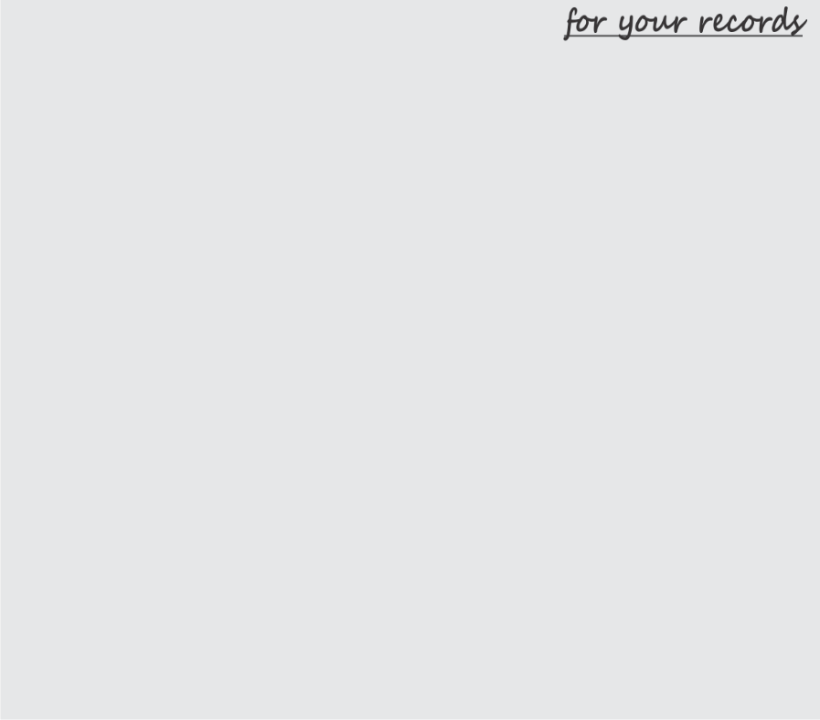
Describe the ideological component of the work, which will show "who is the main character considering the above?"
And describe what is the author in all the above:

What is the relationship between the author and the main character?

The form always depends on the content and "serves" it. The main criterion for the harmony of the form and the content is the artistry of the text.
If we are talking about the genre of non-fiction, you need to find a “golden mean” between form and content, in which the artistic aspect and the business aspect are in the same ratio, then this book will be able to claim high marks on a scale of wide significance.
The interaction between form and content is not the same. The protrusion of the form leads to the inferiority of the content. The same way the reader will assess the weighting of the content in a flat form as disharmony. Any contradictions lead to confusion. If a writer tries to fit a triangle into a square, where the triangle sticks out with its corners outside the form, forming voids (not reaching the form), there is only one verdict: the book is not interesting.
To inveigle the reader into the plot, use the forms that you understand and have experienced. Sincerity is an important quality that attracts the reader. Using it you draw the reader into your world, which is understandable, because it has been experienced.
What will be the final appearance of your work, it will become clear after writing the draft. Analyzing its fragments it is possible to suggest to which form you are leading the reader. And the content reveals the form, as you now know.

Chapter 24. Get up on tiptoe!
Today I am finishing the course of my script-book lecture, but for you it is still just beginning. Now the materials of this book will be useful to you, and the progress of writing your book will be obvious.

Let us summarize what we have done so far:
- Worked on the title of the piece
- Determined the target audience
- Decided on the genre of the work
- We wrote an annotation for the book
- Touched the topic of synopsis
- Learned the rules of text layout and formatting
- We know how many parts we will have in the book and have decided on the conventional names of the parts
- We even know the approximate number of chapters and rough sketches - what is in each chapter
- We touched upon the topic of harmony, virtues and vices in a psychological portrait
- You know that you need a psychological portrait of your main character - a dossier (all the essential details that can affect his behavior: about birth, appearance, life history, motivation, goals)
- Now you know that a work does not exist without conflicts - each conflict must be described (who takes part in it, what is the meaning of the conflict, what is the culmination of the conflict). Conflict is intrigue.
- We have identified the antagonists of your main character. We can even prescribe their hierarchy, a dossier for each. We paint the main ones over the whole page, the secondary ones on half a page (appearance, characters, age, voice or speech features, habits, the moment of with the main character, development of the conflict, and the reason of the emergence of the highest point of the conflict). The antagonist is the creator of the conflict.
- We learned that artistic and visual means will help to make the work rich, emotional, dense. Do not lose sight of the theme of gestures, intonations, and movements of the characters - those pictorial tools that affect the behavior of characters, whether it is a fiction, or non-fiction work.
- We talked about energy words and creative context.
- Now you will intensify using of the dialogues, knowing that they make the texts vivid, and that there are main dialogues and secondary ones.
- Rules for the design of dialogues have replenished your punctuation knowledge.
- The circle-framing rule opened the door to the interaction of form and content.
- We discussed how words-parasites can spoil the text.
- Write down small stories with each antagonist (but these are not chapters yet!!!), this is how the material is collected.
I have listed only what is clearly visible in this book. In its depths, you probably found a lot of information for yourself that will help you feel confidence to create new worlds.

And, finally, one more rule: do not be afraid to share your knowledge, tell your friends about what you have read. This way you become aware of certain topics.
When you give away, the replenishment comes back to you multiplied many times over. Get the opportunity to “fly” and observe what is happening on our big-small planet. Learn "bird" languages ​​- so as not to lose touch with the world of miracles, with history, science and everything we call life filled with happiness and bliss.


